

thread

V1.0



[Date]

[Company name]

[Company address]

# [1]Multi Tasking :

Executing several tasks simultaneously is a concept of Multitasking.

There are two types of multitasking

1. Process based multitasking : Executing several tasks simultaneously where each task is a separate independent program (process) is called process based multitasking.

Ex : While typing a java program in the editor we can listen audio sounds from the same system.

Process based multitasking is based suitable for OS level.

1. Thread based Multitasking : Executing several tasks simultaiously where each task is a separate independent part of same program is called “Thread based multitasking” and each independent part is called a “Thread”.

Thread based multitasking is best suitable at Programmatic level

Note:

Whether it is process based or Thread based the main objective of multitasking is to reduce response time of the system and to improve performance.

# Purpose of Multithreading:

The main important areas of Multithreading are

1. To develop multimedia graphics.
2. To develop animations.
3. To develop video games etc.
4. To develop web servers and application servers etc.

When compare with old languages developing multithreaded application in java is very easy because java provides in build support of multithreading with Rich API.

# Thread creation:

We can define thread by mainly two ways

1. By extending Thread
2. By implementing runnable interface.

# Thread Scheduler :

1. It is part of JVM
2. Responsible to schedule threads i.e. if multiple threads are waiting to get the chance of execution then in which order threads will be executed is decided by thread scheduler.
3. We can’t expect exact algorithm followed by Thread scheduler, it is varied from JVM to JVM hence, and we can’t expect thread’s execution order and exact output. Hence whenever situation comes to multithreading there is no guarantee for exact output, but we can provide several possible outputs.

Difference between t.start() and t. run()?

In the case of t.start() a new thread will be created which is responsible for the execution of run() method but in the case of t.run() a new thread won’t be created and run method will be executed just like a normal method call by main thread.

# Importance of thread class start method :

Thread class start() method is responsible for

1. To register the thread with Thread Scheduler and all other mandatory activities , hence without executing Thread class start method there is no chance of starting a new thread in java, due to this Thread class start() method is consider as Heart of multi-threading;
2. Perform all other mandatory activities,
3. Invoke run method.

Overloading of run() method is always possible but Thread class start() method can invoke no argument run() method, the other overloaded method we have to call explicitly like a normal method call.

If we are not overriding run() method then Thread class run() method will be executed which has empty implementation hence, we won’t get any output.

Overriding of start() method : If we override of start() method then our start() method will be executed just like a normal method call and new thread won’t be created;

It is not recommended to override start() method, otherwise it will not implement multithreading concept;

# Thread Life cycle :

­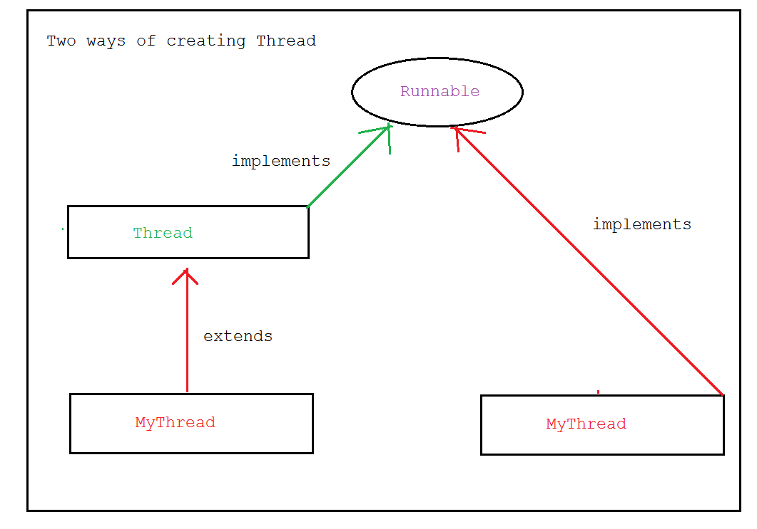

Runnable interface presents in java.lang package and it contains only one method i.e. run().

# Thread State

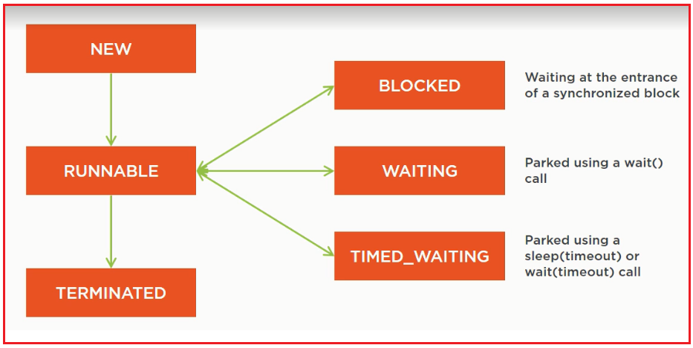

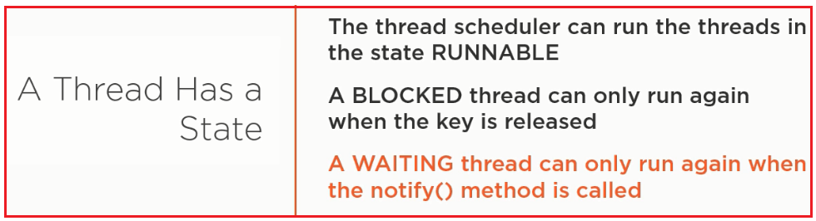

Thread class having a nested class State.

A thread can be in only one state at a given point in time.

These states are virtual machine states which do not reflect any operating system thread states.

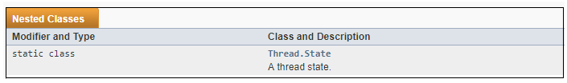

We can get state reference by following approach;

Thread t=…

Thread.State ts=t.getState()

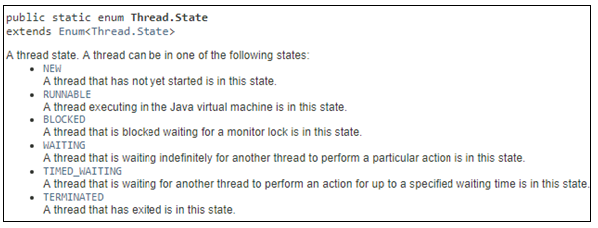

IllegalThreadStateException :

After starting a thread if we are trying to restart the same thread then we will get RuntimeException saying IllegalThreadStateException.

# Case study :

MyRunnable r=**new** MyRunnable();  
Thread t1=**new** Thread();  
Thread t2=**new** Thread(r);

## Case 1 :

t1.start()

A new Thread will be created which is responsible for the execution of Thread class run() method, which has empty implementation;

## Case 2 :

t1.run()

No new thread will be created and Thread class run method will be executed just like a normal method call.

## Case 3 :

t2.start()

A new thread will be created which is responsible for the execution of MyRunnable class run() method .

## Case 4 :

t2.run()

A new thread won’t be created and myrunnable run() method will be executed just like a normal method call.

## Case 5 :

r.start()

We will get compile time error saying MyRunnable class does not have start capability.

## Case 6 :

r.run()

No new thread will be created and MyRunnable run() method will be executed like normal method call

Which Thread creation approach is better?

Among two ways of defining thread, implementing Runnable is better approach.

In the first approach our class always extends thread class, there is no chance of extending any other class, hence we are missing inheritance benefits, but in the second approach while implementing Runnable interface we can extend any other class hence we won’t miss any inheritance benefit.

Because of above reason implementing runnable interface approach is recommended than extending Thread class.

Thread class constructors

Third approach:

MyThread myThread2=**new** MyThread();  
Thread thread=**new** Thread(myThread2);  
thread.start();

Every Thread in java has some name it may be default name generated by JVM or Customized name provided by Programmer.

We can get current executing thread object by using Thread.currentThread() method.

# Thread priority :

Every Thread in java has some priority it may be default priority generated by JVM or Customized priority provided by programmer.

The valid range or Thread priority is 1 to 10 where 1 is MIN_PRIORITY and 10 is MAX_PRIORITY.

Thread class defines following constants to represent some standard priority

They are:

* + Thread.NORM_PRIORITY =5;
  + Thread. MIN_PRIORITY =1;
  + Thread.MAX_PRIORITY = 10;

Thread Scheduler will use priorities while allocating processors.

The thread which is having highest priority will get chance first.

If two thread having same priority then we can’t expect exact execution order. It depends on Thread scheduler.

Thread class defines The following methods to get and set priority of thread:

* Public final int getPriority()
* Public final void setPriority(int p) for allowedvalues range 1 to 10;

Otherwise Runtime exception: IllegalArgumentException:

Ex; t.setPriority(17) will throw exception;

Default Priority: The default priority only for the main thread is 5 but for all remaining threads default priority will be inherited from parent to child. i.e. whatever priority parent thread has the same priority will be there for the child thread.

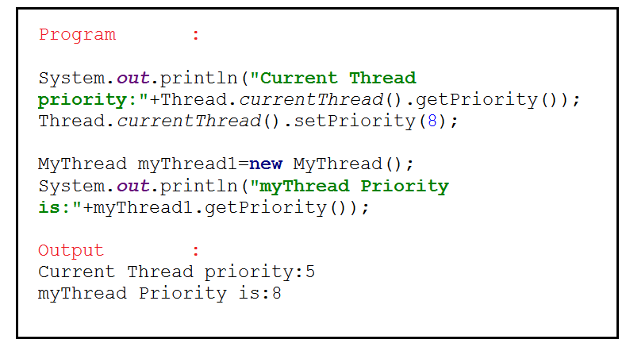

Some platforms won’t provide proper support for thread priorities

# Thread creation using Inner loop:

# Thread property

1. A thread is nothing but a thread of execution which executes the code. Then..
2. Every application has threads running in the background. Without threads, there will be NO application that will run.
3. When you use java class – your main method starts getting executed – It means that the JVM is creating a thread to start executing the code in main method and we call this method as Main thread.
4. It is the Operating System which schedules the threads to be processed by the Processor. So the scheduling behaviour is dependent on the OS. Again there is a Thread Scheduler inside JVM which coordinates with OS scheduler.
5. Remember that there is nothing that is guaranteed when it comes to the thread execution.  Do not bet that your thread will be executed at a time or so.. There is no guarantee..

Thread creation

1. Extending Thread class
2. Implementing runnable interface
3. Inner loop

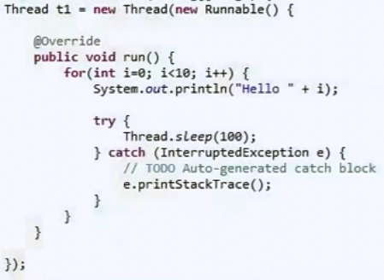

# Thread Methods

We can prevent a thread execution by using following these three methods:

* yield()
* sleep()
* join()

## Yield()

### Signature

It’s also native static method:



### Diagram:

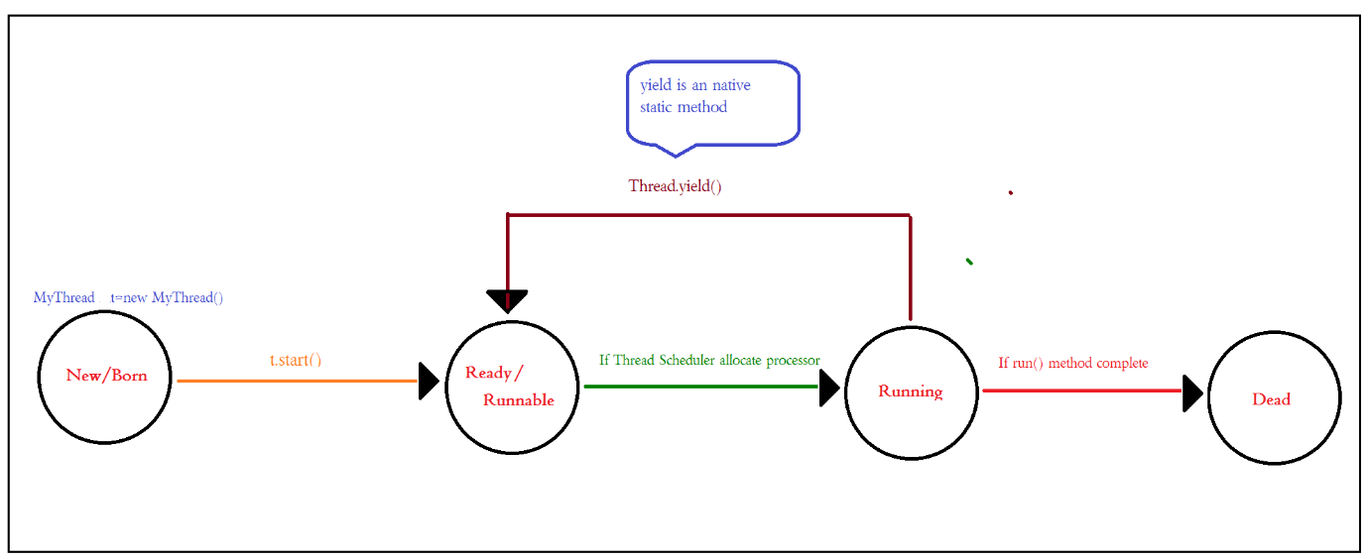

### Property:

1. **Yield() method causes to pause current executing thread to give the chance for waiting Threads of same priority, If there are no waiting thread or all waiting threads have low priority then same thread can continue its execution**.
2. If multiple threads are waiting with same priority then which waiting thread will get the chance we can’t expect. It depends on Thread scheduler.
3. The thread which is yielded when it will get the chance once again that depends on Thread Scheduler and we can’t expect exactly.
4. Yield tells the currently executing thread to give a chance to the threads that have equal priority in the Thread Pool.
5. There is no guarantee that yield() will make the currently executing thread to runnable state immediately.
6. Some platform won’t provide proper support for yield method.(because it is native method and java don’t provide support of that).
7. Remember an important point that yield method does not make the thread to go to Wait or Blocked state. It can only make a thread from Running State to Runnable State.
8. If more processing is there in middle of that yield method using is recommended.

### Reprentation:

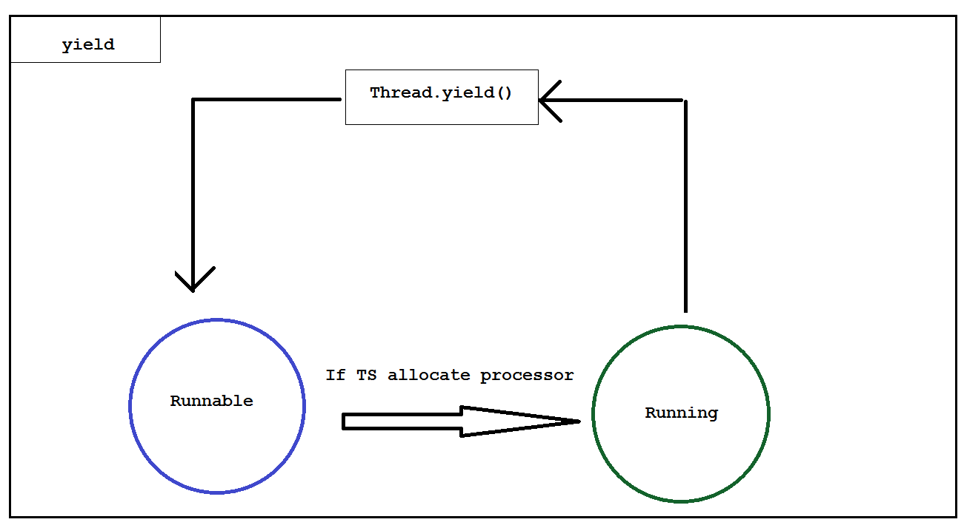

### Program:

#### Normal Approach:

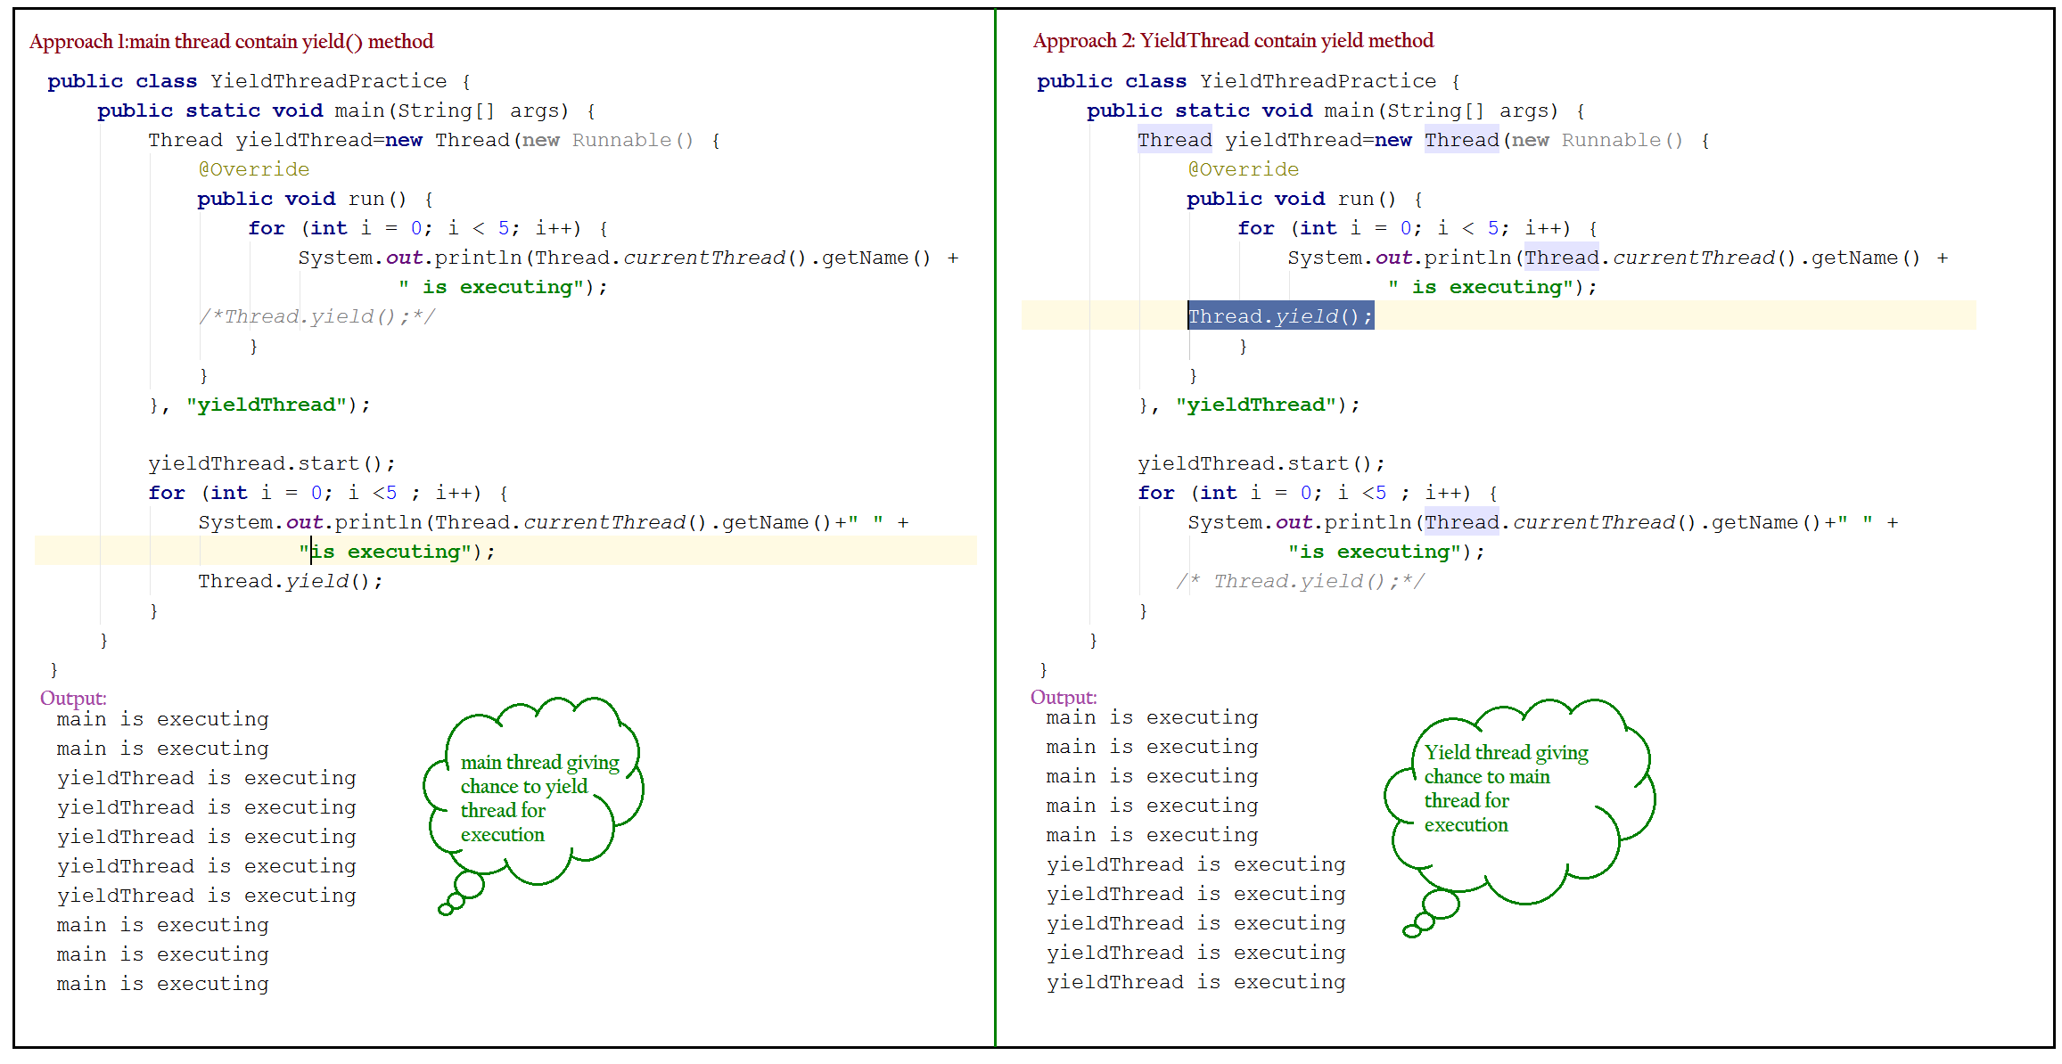

If **Thread.yield()** is commented both execute simultaneously, and we can’t expect which thread will complete first, if we are enabling that in **YieldThread** Then **YieldThread** always calls yield() method because of that, main thread will get chance more no of times and chance of completing main thread first is high.

#### Lambda Approach:

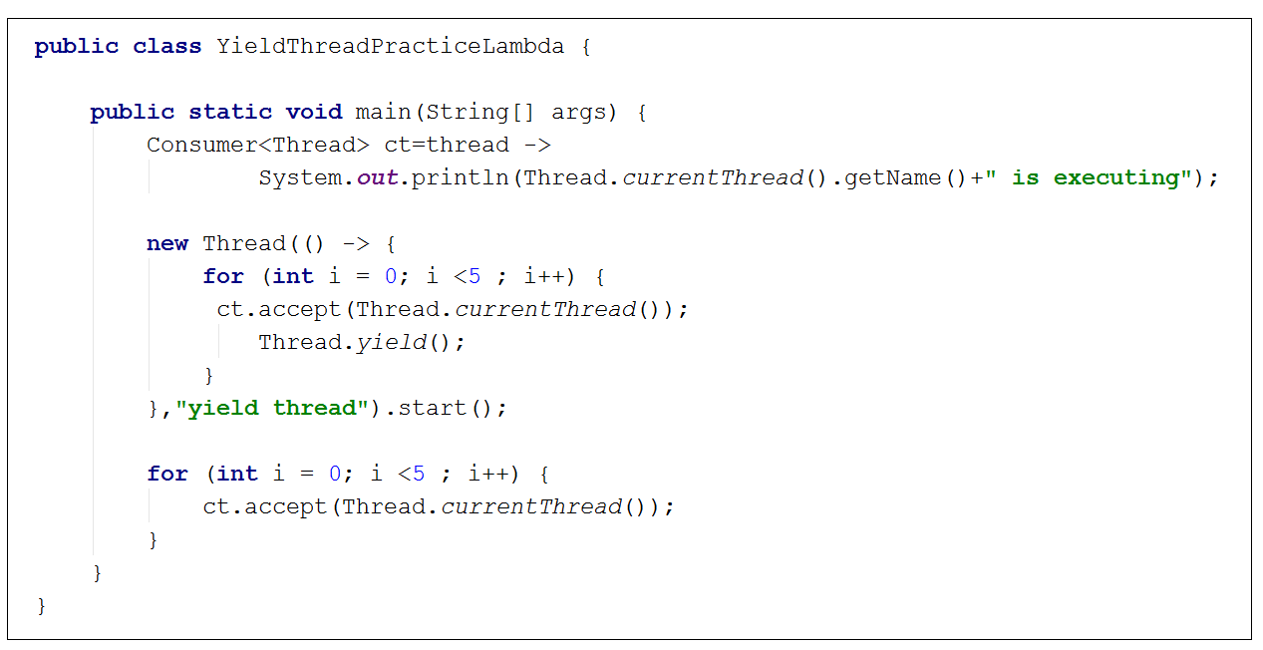

## Join()

### Property

1. **If a thread wants to wait until complete of some other thread then we should go for join() metho**d. For ex. If a thread t1 wants to wait until completing t2 then t1 has to call t2.join().
2. If t1 executes t2.join() then immediately t1 will be entered into waiting state until t2 completes.
3. Once t2 completes then t1 can continue its execution.

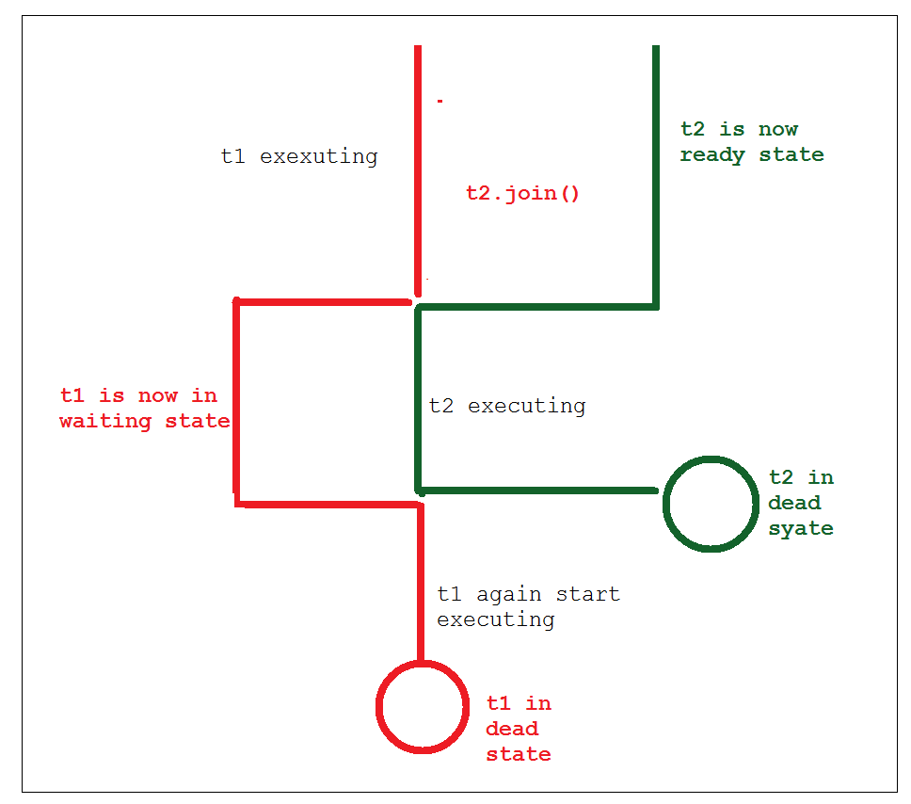

1. *Join method belongs to Thread object and not a static member*. When join is invoked on a thread instance, this thread will tell currently executing thread to wait till the Joining thread completes.
2. Join is used in the situations when a task which should be completed before the current task is going to finish.

### Real Time Example:

#### Ex1:

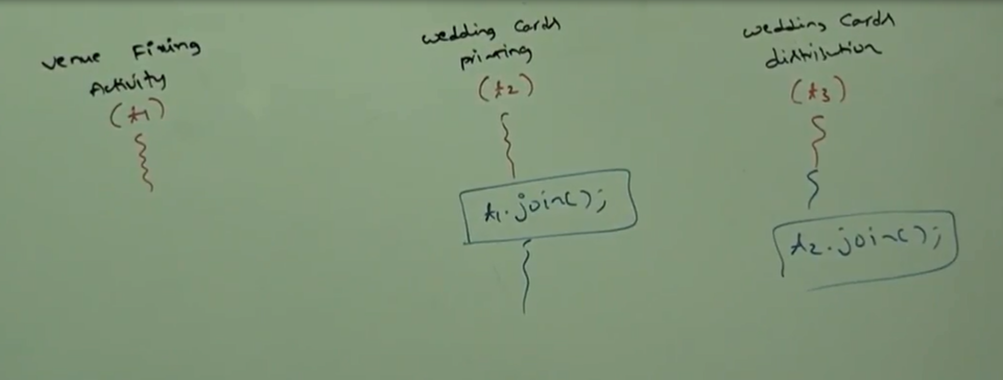

* Wedding card Printing thread (t2) has to wait until Venue fixing thread (t1) compilation hence t2 has to call **t1.join ().**
* Wedding card distribution thread(t3) has to wait until Wedding card Printing thread(t2) hence t3 has to call **t2.join().**

#### Ex2:

Just to give another example of how Join works, say we have a slow train on the track moving and another fast train should take the same track, so, we make way to the fast train and tell the slow train to join once after the fast one is left.

#### Note:

1. If a **thread t1 wants to wait until completing t2 then t1 has to call t2.join()**.
2. If t1 execute t2.join() immediately t1 will enter to waiting state until t2 completes.
3. Once t2 completes then t1 can continue its execution.

### Prototype:

#### Join Immediately

#### Join with time stamp

Join is also possible for a time period then it takes :

* 1. 1st parameter of time in long datatype and mill second unit.
  2. 2nd parameter of time in int datatype and nano seconds unit.

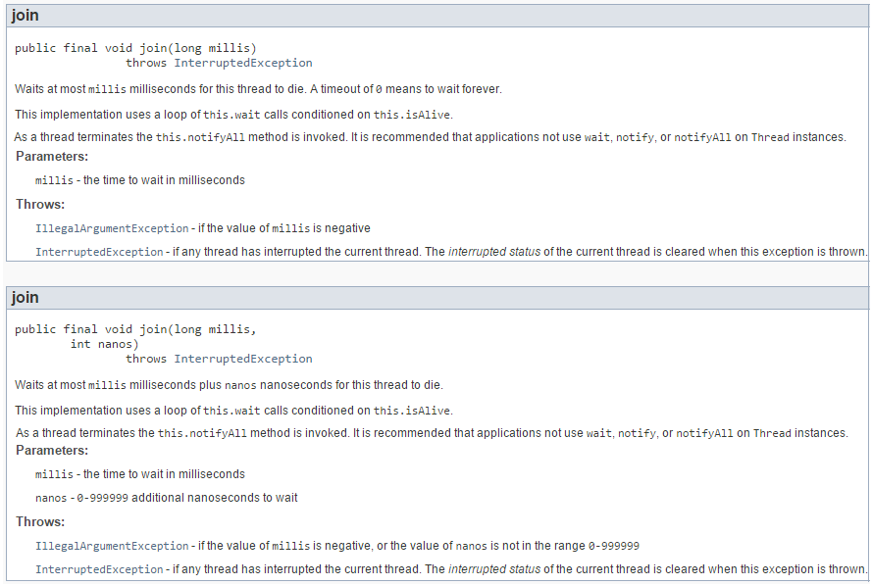

### Interrupted Exception:

Every join() method throws interrupted exception known as **InterruptedException** (it is Checked exception) which compulsory we should handle either by using try catch or by throws keyword, otherwise we will get compile time error.

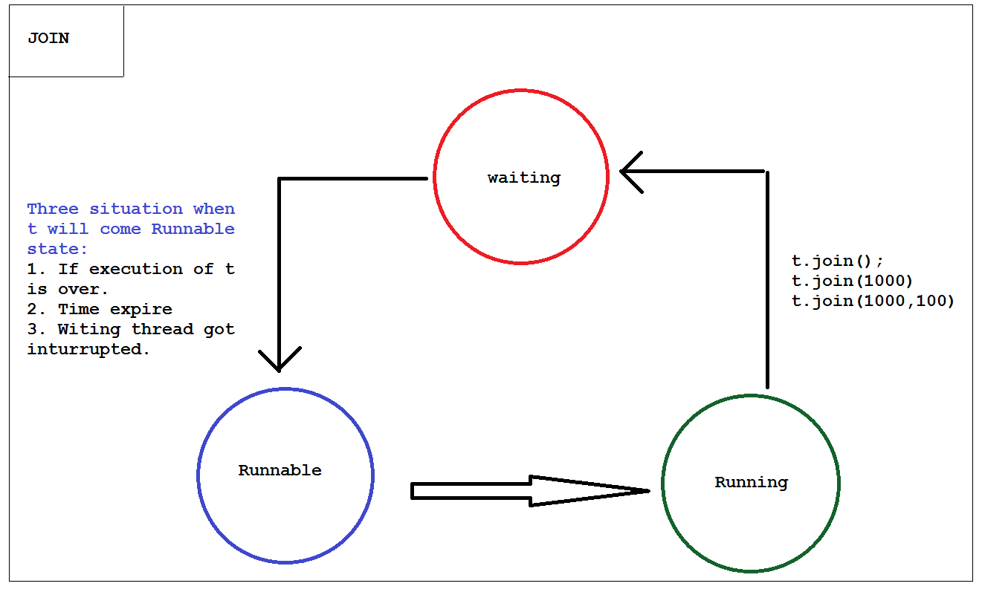

If main thread call join method on child thread object and child thread call join on main thread object then both thread wait for ever and the program will stuck, this is something like Dead lock.

Other way if a thread calls join method on same itself , then also program will be stuck. This is something like deadlock and in this case thread has to wait infinite amount of time

Thread.curreantThread().join();

## Sleep() :

1. **If a thread don’t want to perform any operation just want to take pause for few time the method call sleep() method**
2. Signature : This is method of java.lang.thread class(its native method)

* public static void sleep(long millis)

throws [InterruptedException](https://docs.oracle.com/javase/7/docs/api/java/lang/InterruptedException.html)

* public static void sleep(long millis,

int nanos)throws [InterruptedException](https://docs.oracle.com/javase/7/docs/api/java/lang/InterruptedException.html)

1. Sleep method in Thread tells the currently executing thread to sleep for specified amount of time, there is no sleep method which does not accept time argument;
2. Every sleep method throws interrupted exception, which is checked exception hence whenever we are using sleep method compulsory we should handle InturruptedException either by try catch or by Throws key word otherwise we will get compile time error.

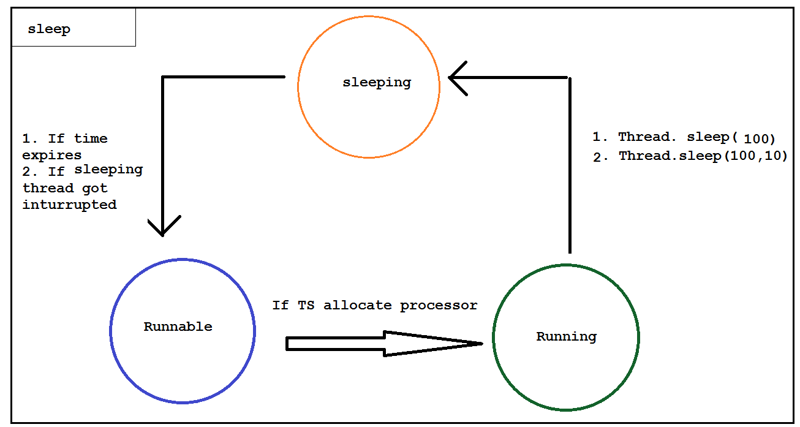

1. The thread **does not lose ownership of any monitors**.
2. Sleep method accepts the time in Milliseconds.
3. It can throw InterruptedException . So it should be embedded in the try catch block or throws
4. There are main two situation when sleeping thread goes to runnable state.
   * Sleeping time expired
   * Interrupted by thread scheduler
5. Remember that there is no guarantee that the thread will go to Sleep state the moment is it executed and no guarantee that the thread will sleep for specified amount of time. The thread scheduler can wake it up any time.
6. Once the thread completes or out of its sleep state, it can move to Running or Runnable state.

A thread can interrupt a sleeping thread or waiting thread by using interrupt() method of Thread class.

A thread can interrupt a sleeping thread or waiting thread by using interrupt method of Thread class

public void interrupt()

* Whenever we are calling interrupt method if the target thread not in sleeping state or waiting state then there is no impact of interrupt call immediately, Interrupt call will be waited until target thread entered into sleeping or waiting state.
* If the target thread enter into sleeping or waiting state then immediately interrupt call will interrupt the target thread.
* If the target never enter into sleeping or waiting state in its lifetime then there is no impact of interrupt call, this is the only case where interrupt call is wasted.

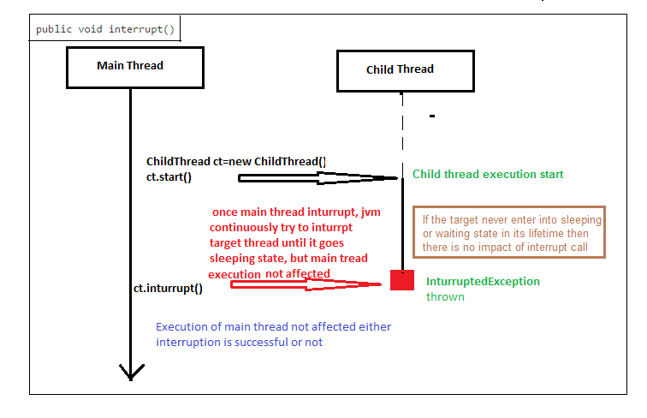

Deprecated methods are

* Stop()
* Suspend()
* Resume()
* Destroy()

## Stop():

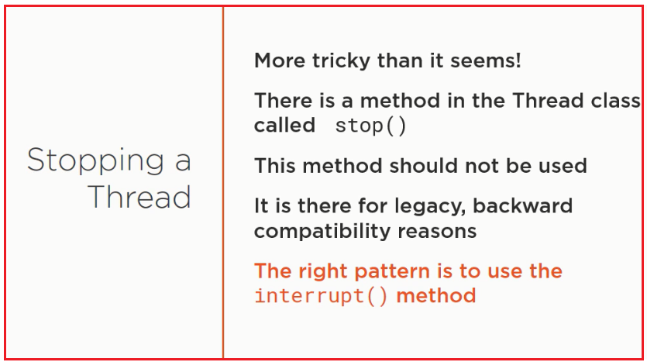

Note:

Interrupt() method not stop a thread but marely send a signal to the task which is running, that it is time to stop the task the thread is running;

## Interrupt()

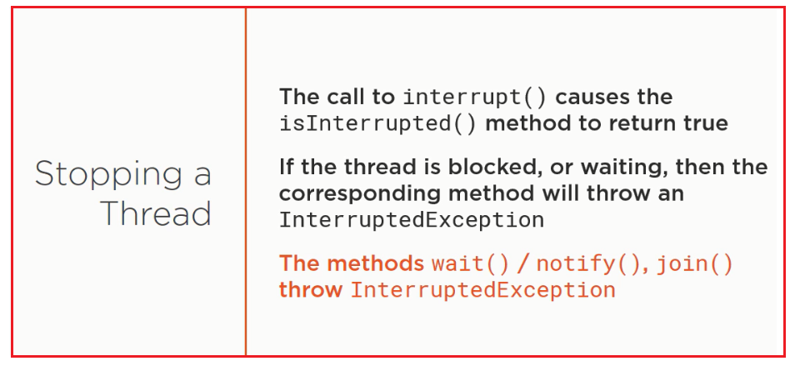

# Comparison among Thread methods:

|  |  |  |  |
| --- | --- | --- | --- |
|  | Yield | Join | sleep |
| Purpose | If a thread wants to pause its execution to give the chance for remaining threads of same priority then we should go for yield method. | If a thread wants to wait until completing some other thread then we should go for join() method | If a thread don’t want to perform any operation for a particular amount of time then we should go for sleep() method. |
| Is it overloaded? | No | yes | Yes |
| Is it final? | No | yes | no |
| Is it throw inturruptedException? | No | Yes | yes |
| Is it native? | yes | np | Sleep(long ms): yes  Sleep(long ms,int ns):no |
| Is it static? | Yes | no | yes |

# Threading Philosophies:

## Visibility:

It is about informing other caches of CPU that variable has been modified and that right value is in one of the cache of CPU and should not be fetch from memory.



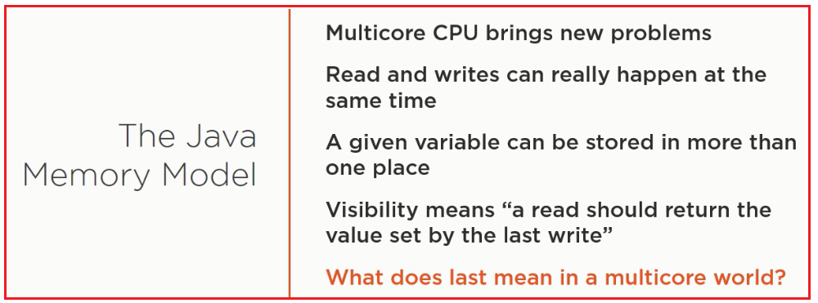

Actually for this mainlining happen before there is no inbuild mechanism rather we have to maintain it.

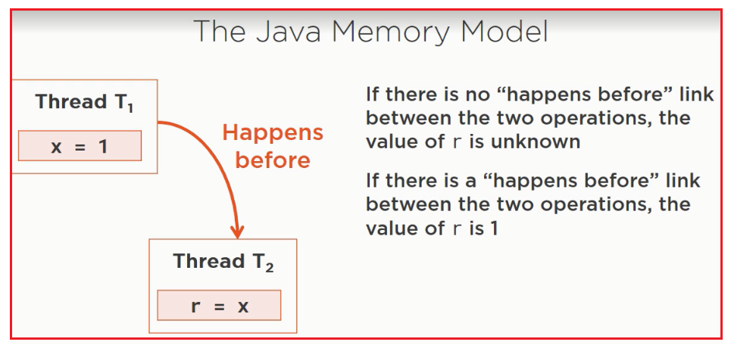

## Happens –before:

Java doc there are many reference of "happens before"

* Blocking queue
* Cyclicbarrier
* CountDownLatch

It is not explained in Java-Doc rather in java language spesificiation in a chapter "jave Memory Model"

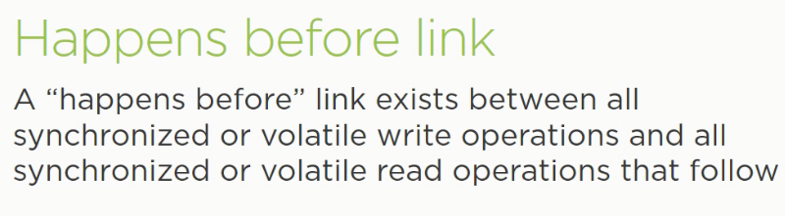

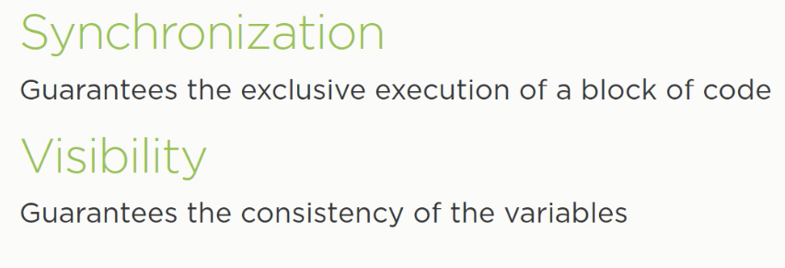

All shared variables (shared among more than one thread) should be accessed either by synchronized way or volatile way.

If a variable or piece of code read and write by more than one thread at same time and that is neither synchronized nor volatile then there is high chance of "race condition"

## False Sharing:

False sharing happens almost invisible way and it is very hard to predict.

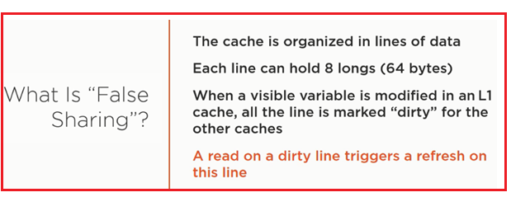

# Synchronization:

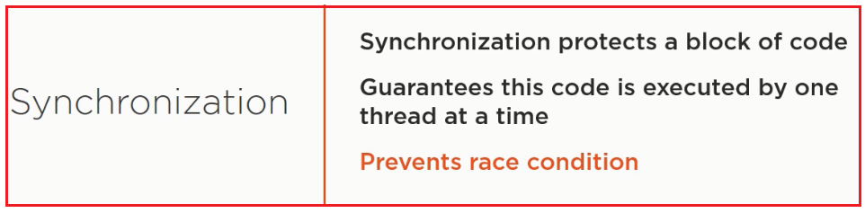

## Properties

1. *Synchronized is the modifier applicable only for methods and blocks* but not for classes and variables
2. If multiple threads are trying to operate simultaneously and the same java object then there may be a chance of data inconsistency problem. To overcome this problem we should go for “**Synchronized**” keyword.
3. If a method or block declared as synchronized then at a time only one thread is allowed to execute that method or block on the given object, so that data inconsistency problem will be resolved.
4. The main advantage of Synchronized keyword is we can **resolve data inconsistency problems** but the main disadvantage of Synchronized keyword is it increased waiting time of thread and create performance problem, hence if here is no specific requirement then it is not recommended to use Synchronized keyword.
5. Internally synchronization concept is implemented by using lock. Every object in java has a unique lock, whenever we are using synchronized keyword then only lock concept will come into the picture.
6. If a thread wants to execute synchronized method on the given object first it has to get lock of that object, once thread got locked then it is allowed to execute any synchronized method on that object. Once method execution completes automatically thread releases lock.
7. Acquiring and releasing lock internally takes care by JVM and programmer not responsible for these activities.
8. **While a thread executing synchronized method on the given object the remaining threads are not allowed to execute any synchronized method simultaneously on the same object but remaining threads are allowed to execute non-synchronized method simultaneously.**
9. In the following example t1 came to execute synchronized m1() method, if t2 comes to execute same m1 method or other synchronized m2 method goes to waiting state, t3 if try to execute normal method m3 its face no issue.

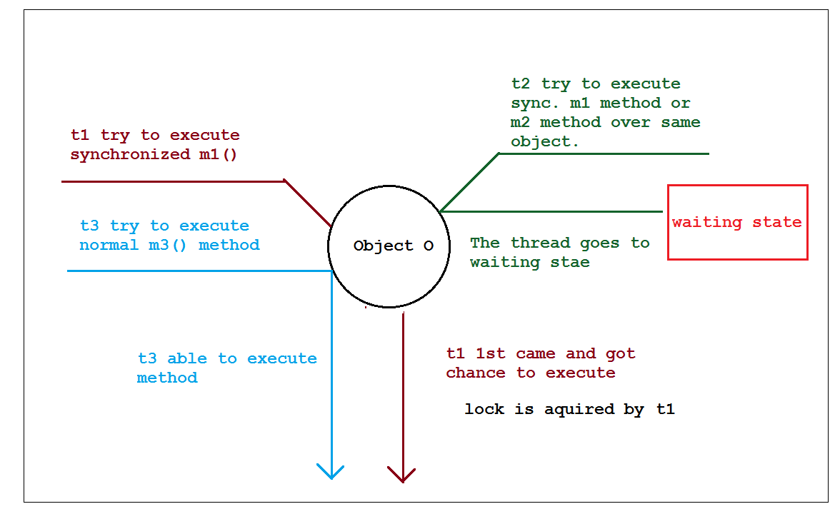

1. Lock concept is implemented based on object but not based on method.

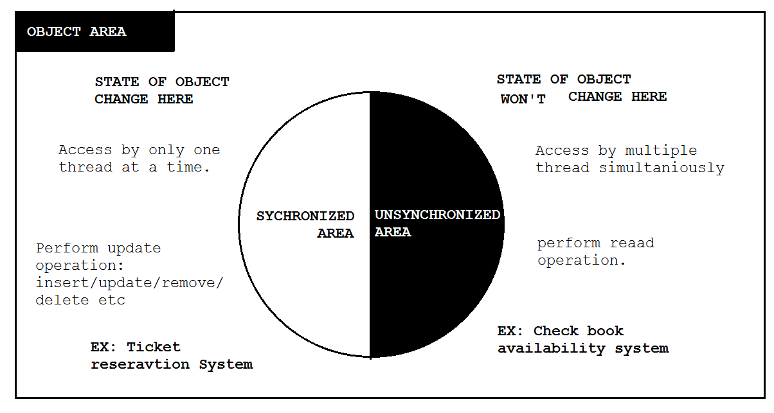

1. If we don’t declare any method as synchronized at a time multiple thread can access the method and we may get irregular output, if we declare that same method as synchronized at a time only one thread is allowed to execute particular method, hence we will get regular output.
2. Case Study : For synchronize method also we can get irregular output if threads are operating on different java objects. I multiple threads are operating in same object then synchronization required, but if multiple threads are operating in multiple java objects then synchronization is not required.
3. **Class level lock** : Every class in java has a unique lock which is also known as “**Class Level lock**”. If a thread wants to execute a static synchronized method then thread required class level lock. Once thread got class level lock then it is allowed to execute any static synchronized method of that class, once methods execution completes automatically thread releases lock.
4. While a thread executing static synchronization method the remaining threads are not allowed to execute any static synchronized method of that class simultaneously but remaining threads are allowed to execute the following methods simultaneously
   1. Normal static method
   2. Synchronized instance method
   3. Normal instance methods

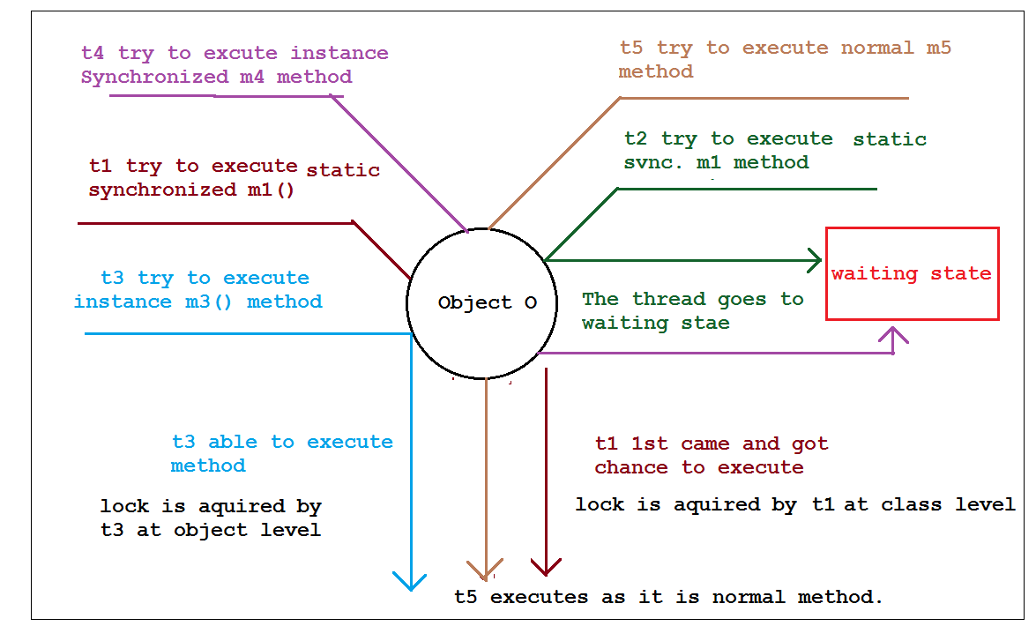

## Programs

### Program 1:

Situation 1 without Synchronization:

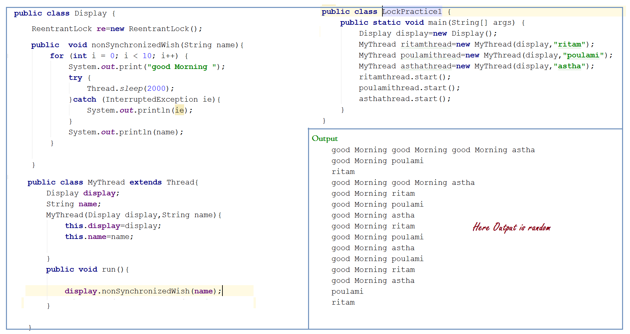

If we are not declaring “wish” method as synchronized then both threads will be executed simultaneously and hence we will get irregular output.

### Program 2:

Program with Synchronized method:

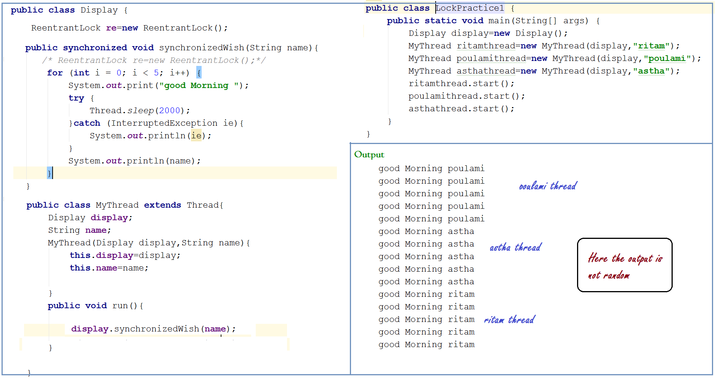

If we are declaring wish method as synchronized then at a time only one thread is allowed to execute wish method on the given “display” object hence we will get regular output.

### Program 3:

Synchronized Method Example with lambda Expression

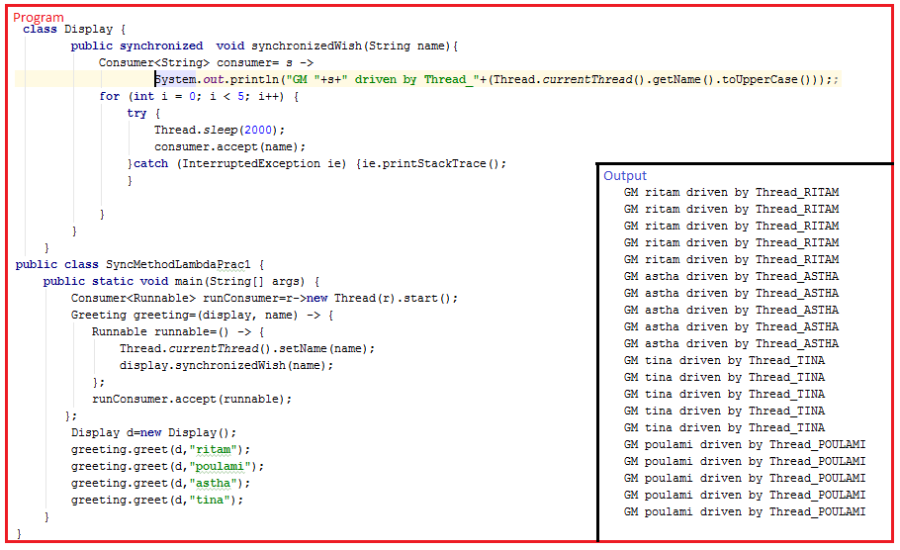

### Program 4:

If multiple thread is working on same java object only then only synchronization needed but if they are working on different java object then synchronization not needed.

In this case we will get irregular output;

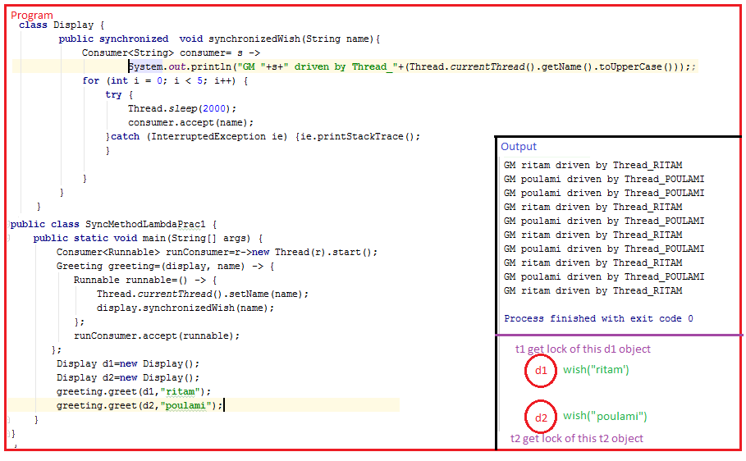

Even though “wish” method is synchronized we will get irregular output because threads are operating on different java objects.

Conclusion:

If multiple threads are operating on same java object then synchronization is required.

If multiple threads are operating on multiple java objects then synchronization is not required.

### Program 5:

We can achieve unique class level lock by using “static synchronized” method and on that situation if multiple thread is associate with different object we can get regular output.

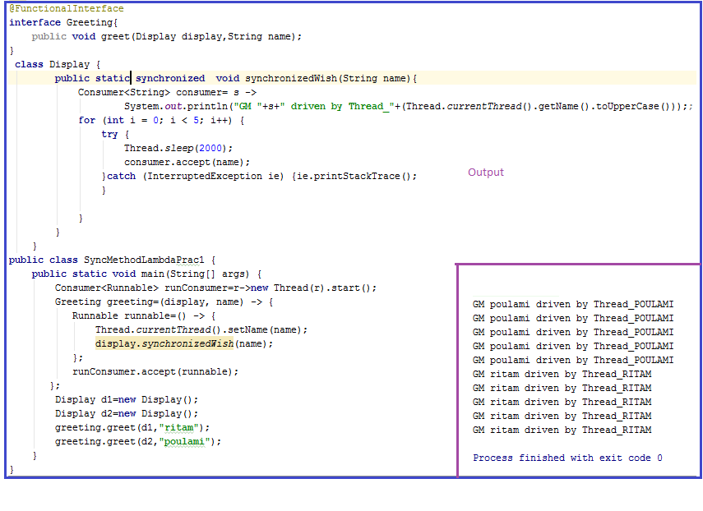

### Program 6:

Here both thread working on different method, hence no locking acquired by any thread

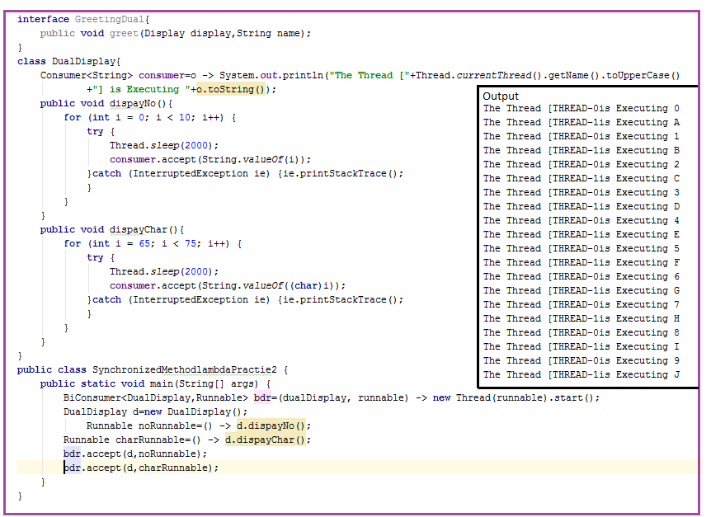

### Program 7:

If both methods are synchronized we expect regular output

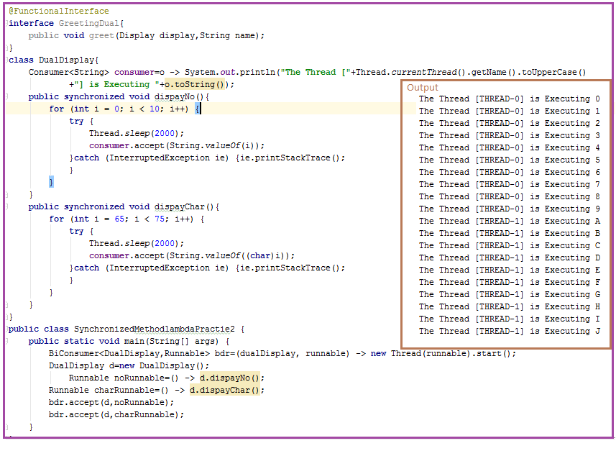

Class Level lock

Every class in java has a unique lock which is nothing but class level lock.

If a thread wants to execute a static synchronized method then thread required class level lock.

Once thread got class level lock then it is allowed to execute any static synchronized method of that class.

Once method’s execution complete, automatically thread releases the lock.

# Race condition :

## Definition

If multiple threads are operating simultaneously on same java object then there may be a chance of data inconsistency problem. This is called Race condition.

We can overcome this problem by using synchronized keyword

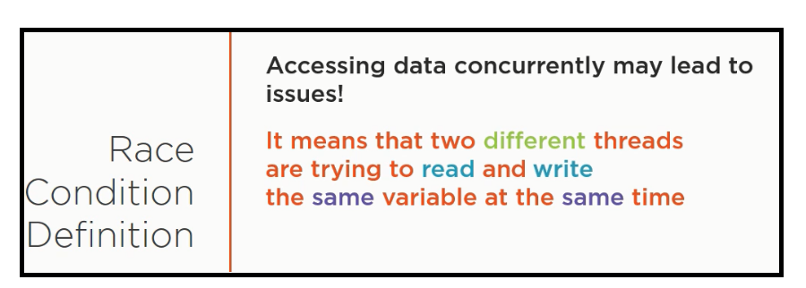

## Classic Race Condition

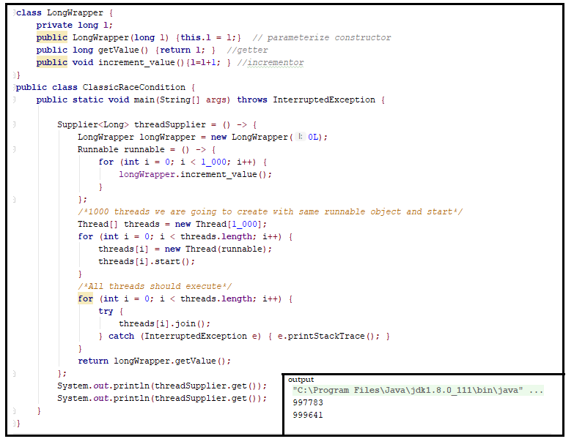

Just changing to this piece of code every time we can get same value:

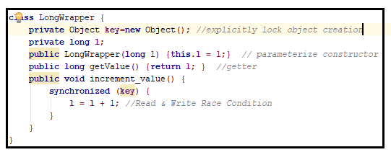

This is consider as “resolver of race Condition”

# Synchronized Block:

## Property:

1. If very few line of the code required synchronization then it is not recommended to declare entire method as Synchronization. We have to enclose those few lines of the code by using Synchronized block.
2. The main advantage of Synchronized block over synchronized method is it reduces waiting time of threads and improves performance of the system.
3. We can declares Synchronized block as follows :
   1. To get lock of current object:

synchronized(this){

….

….

….

}

If a thread got lock of current object, then only it is allowed to execute the enclosed area.

* 1. To get lock of particular object:

synchronized(display){

….

….

….

}

If a thread got lock of particular object say display then only it is allowed to execute the enclosed area.

* 1. To get class level lock

synchronized(Display.class){

….

….

….

}

If a thread got class level lock of Display class then only it is allowed to execute enclosed area followed by synchronized block

1. Lock concepts applicable for object types and class types but not for primitives, hence we can’t pass primitive type arguments to synchronized block, otherwise we will get compile time exception. Like:

“UnexpectedType:find int required reference”

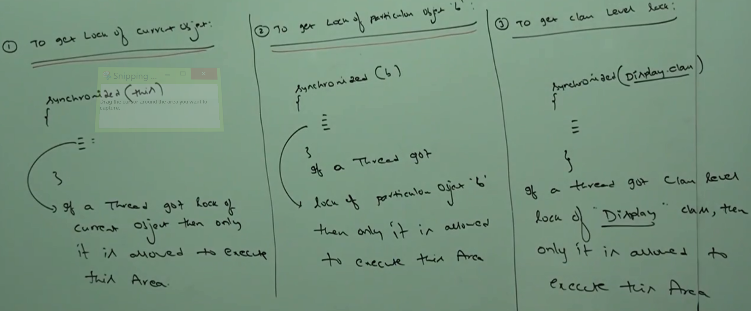

## Programs:

### Program 1:

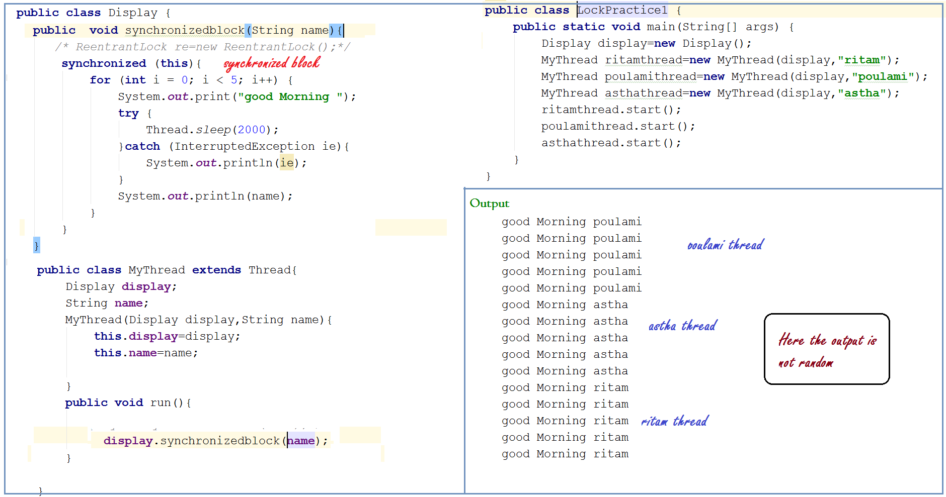

### Program 2

Here function Interface WishThread doing same work which Display class was doing.

And MyThread responsibility is taken by DisplayNameInterface.

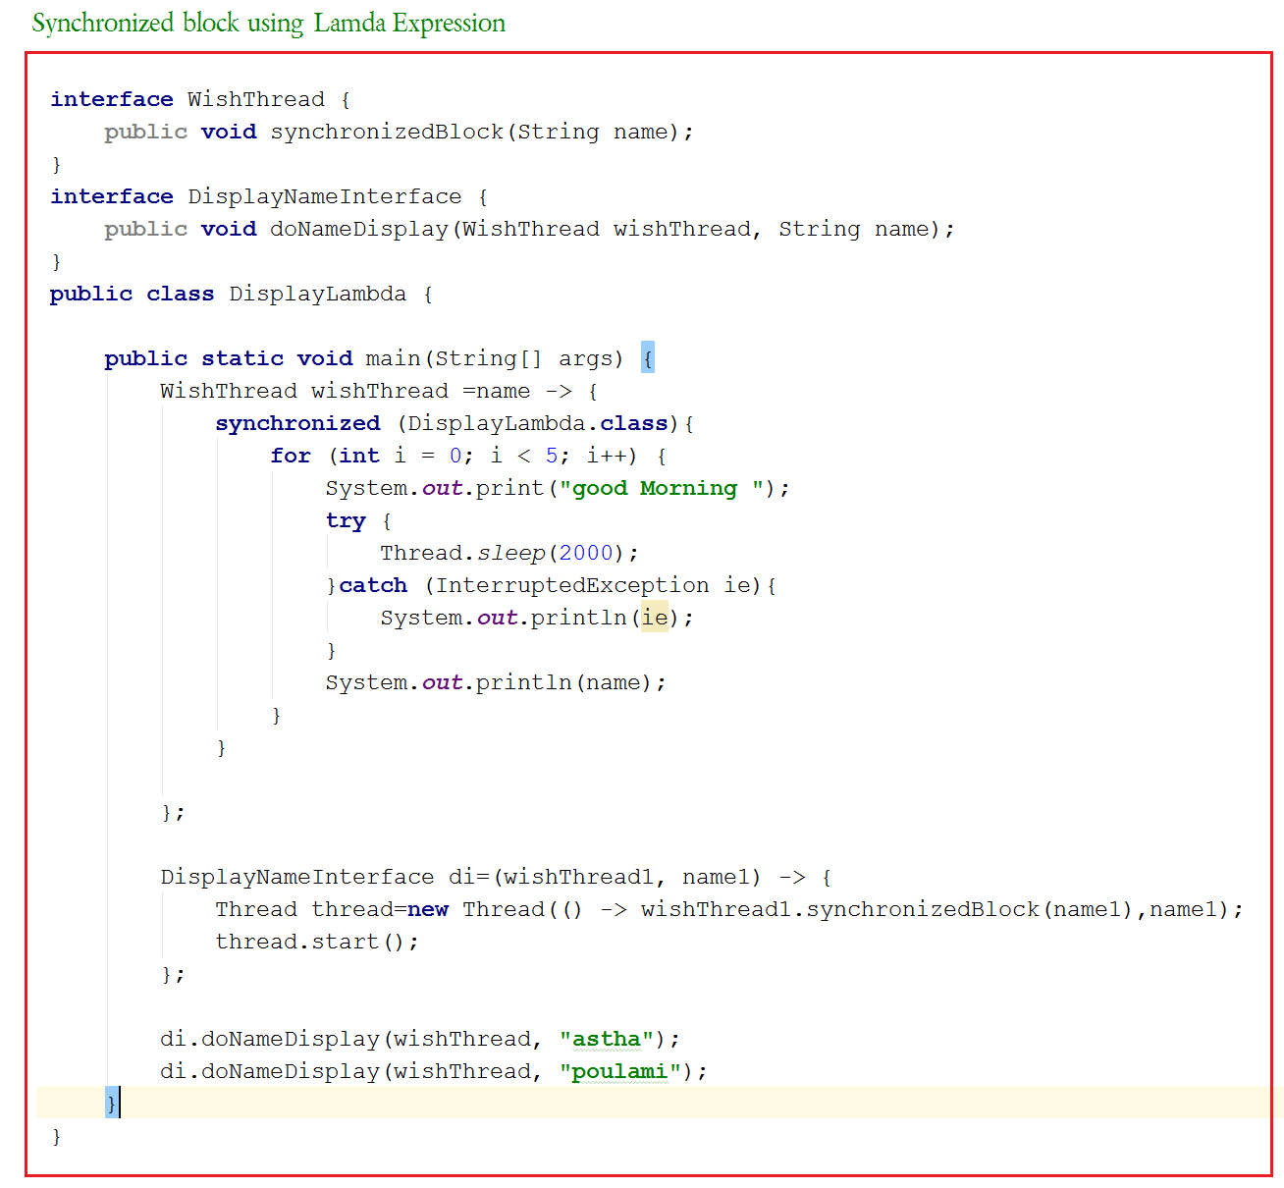

FAQ:

1. What is synchronized keyword where we can apply?
2. Explain advantage of Synchronized keyword?
3. Explain disadvantage of synchronized keyword?
4. What is race condition?
5. What is object lock and when it is required?
6. What is class level lock and when it is required.
7. What is difference between class level lock and object level lock?
8. While a thread executing synchronized method on the given object is the remaining thread are allowed to execute any other synchronized method simultaneously on the same object?
9. What is synchronized block?
10. How to declare synchronized block to get lock of current object?
11. How to declare synchronized block to get class level lock?
12. What is the advantage of synchronized block over synchronized method?
13. Is a thread can acquire multiple lock simultaneously? YES
14. What is synchronized statement?

## Case study:

Class X{

{

Public synchronized void m(){

{

Y y= new Y();// lock is over x object

Synchronized(y){

Z z= new Z();// lock is over x, y objects

Synchronized(z){

….

…. // lock is over x, y ,z objects ….

}

}

}

# Synchronized statement :

The statement present within synchronized method and synchronized block are called synchronized statement.

Inter thread communication :

## Property:

1. Two threads can communicate with each other by using wait(), notify() and notifyAll() methods.
2. The thread which is expecting update is responsible to call wait() method then immediately the thread will enter into waiting state.
3. The thread which is responsible to perform update, after update it is responsible to call notify() method then waiting thread will get that notification and continue its execution with those updated items.

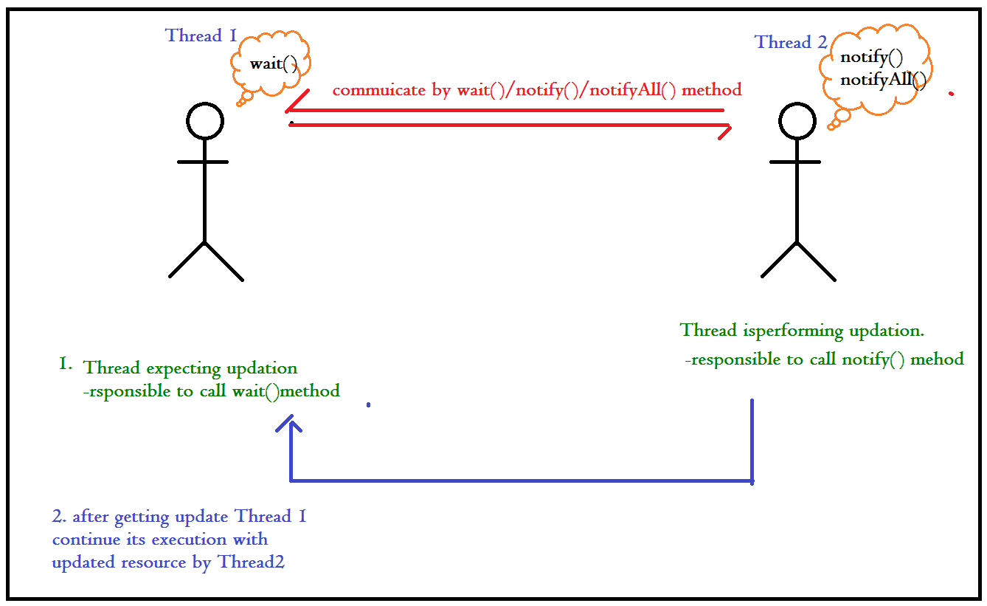

1. wait(), notify(), notifyAll() methods present in object class but not in thread class because thread can call these methods on any java object.
2. To call wait(), notify(), notifyAll methods on any object thread should be owner of these objects i.e. thread should have lock of that object, i. e. thread should be inside synchronized area, hence we can call wait(), notify(), notifyAll() method only from synchronized area otherwise we will get runtime exception saying “IllegalMonitorStateException()” ;

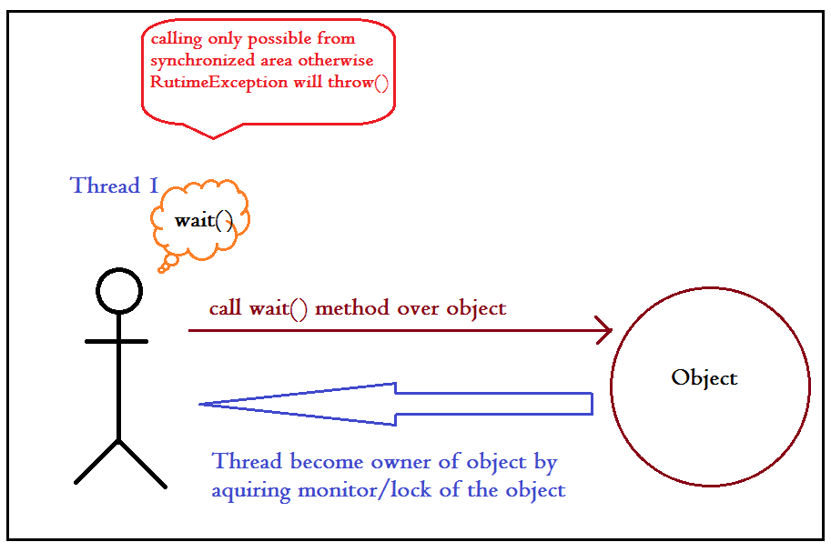

1. If a thread calls wait() method on any object it **immediately release** lock of that particular object and entered into waiting state.
2. If a thread call notify() method on any object it **releases the lock of that object but may not immediately**.
3. **Except wait (), notify (), notifyAll () there is no other methods where thread releases lock.**

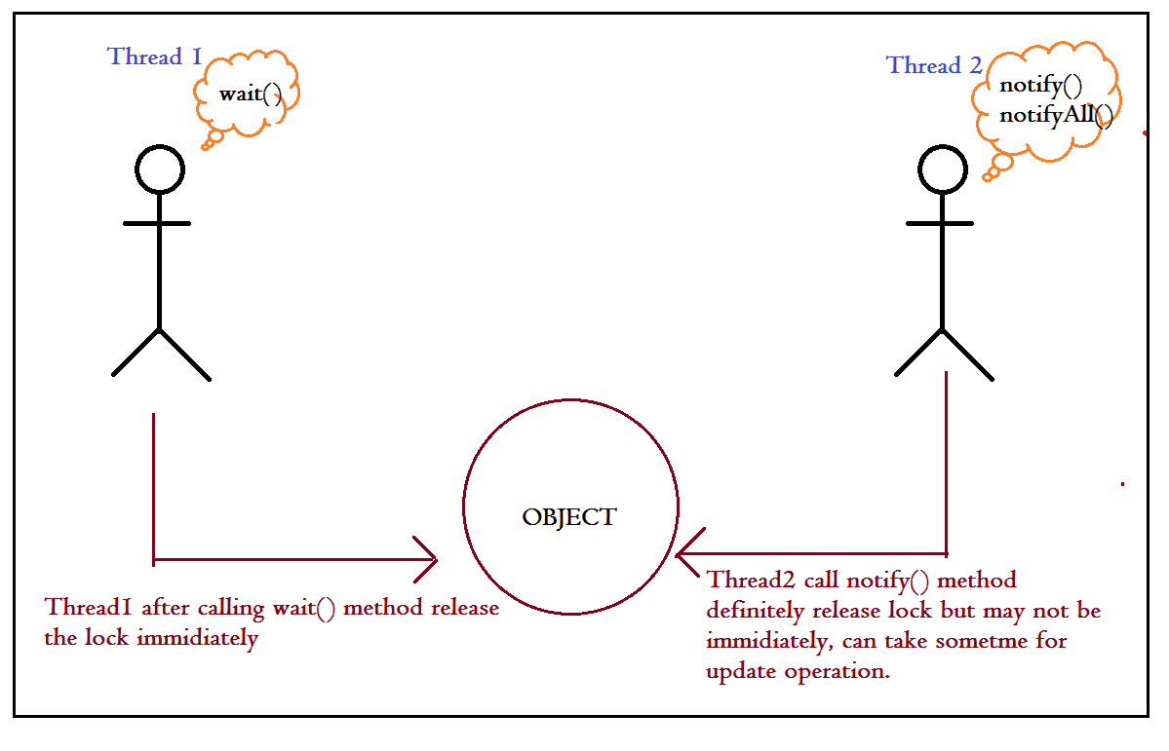

## Case studies:

### Case 1

|  |  |  |  |
| --- | --- | --- | --- |
|  |  | **Method** | **Is release Lock?** |
| 1 |  | sleep() | No |
| 2 |  | join() | No |
| 3 |  | yield() | No |
| 4 |  | wait() | Yes |
| 5 |  | notify() | Yes |
| 6 |  | notifyAll() | Yes |

### Case2

|  |  |  |
| --- | --- | --- |
|  | **Situation** | **True/False** |
| 1 | If a thread calls wait method immediately it will enter into waiting state without releasing any lock | false |
| 2 | If a thread calls wait method it releases the lock of that object but may not immediately | false |
| 3 | If a thread calls wait() method on any object it releases all locks acquired by that thread and immediately enter into waiting sate | false( it won’t release all lock only particular method) |
| 4 | If a thread call wait method on any object it immediately release the lock of that particular object and enter into waiting sate | true |
| 5 | If a thread calls notify method on any object it immediately releases the lock of that particular object | False (immediately not applicable here). |
| 6 | If a thread calls notify method on any object it releases the lock of that object but may not immediately | true |

## All porotype methods

1. public final void wait()

throws [InterruptedException](https://docs.oracle.com/javase/7/docs/api/java/lang/InterruptedException.html)

1. public final void wait(long timeout)

throws [InterruptedException](https://docs.oracle.com/javase/7/docs/api/java/lang/InterruptedException.html)

1. public final void wait(long timeout,

int nanos)

throws [InterruptedException](https://docs.oracle.com/javase/7/docs/api/java/lang/InterruptedException.html)

1. public final void notify() //native method
2. public final void notifyAll() // native method

## Conclusions:

### Conclusion 1

Every wait () method throws **InturruptedException** which is checked exception hence whenever we are using wait() method compulsory we should handle this interrupted exception either by try-catch() or by throws keyword, otherwise we will get compile time error.

### Conclusion2

If a waiting thread got notification, it will come to another waiting state to get the lock, because to go ready/runnable state object lock is required.

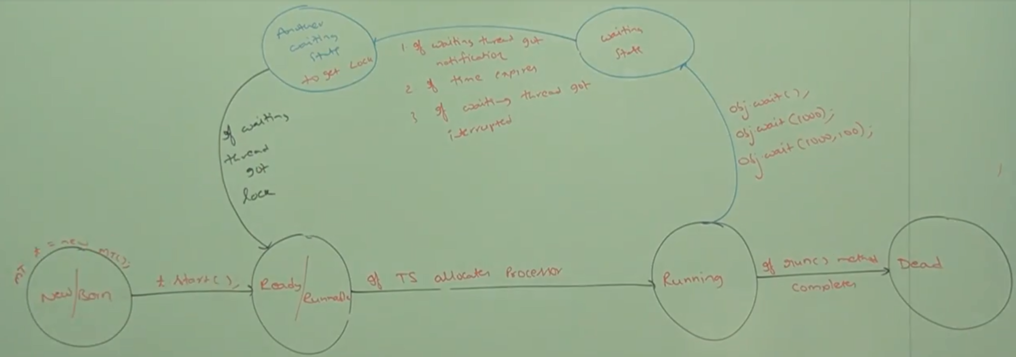

<part 10 complete>

<part 11 start>

## Example:

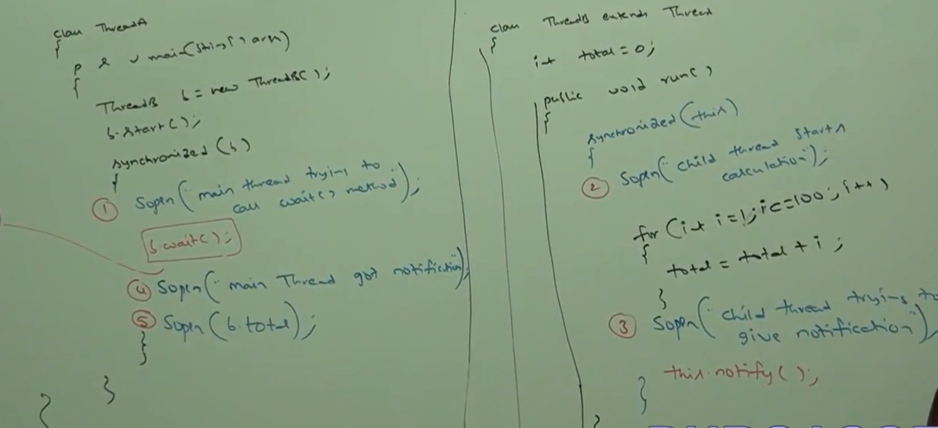

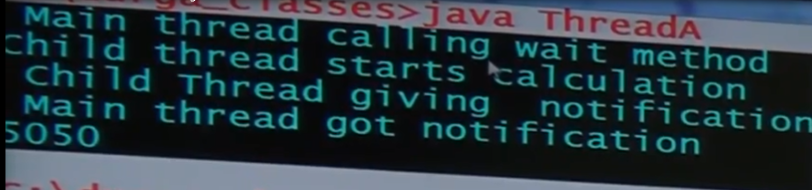

In the following situation sleep() is not applicable because for updating may take less time that the time for which first thread going for sleep.

Join is not good choice because if after update ThreadB performing other operations too, those will be executed and then control will return back to main thread.

If tere is no gurentee that someonle will notify the waiting thread we can provide timestamp within wait, so that after that time automatically waiting thread will start to execute.

Code : b.wait(10000);

# Producer-Consumer problem :

Producer thread is responsible to produce items to the queue and the consumer thread is responsible to consume items from the queue.

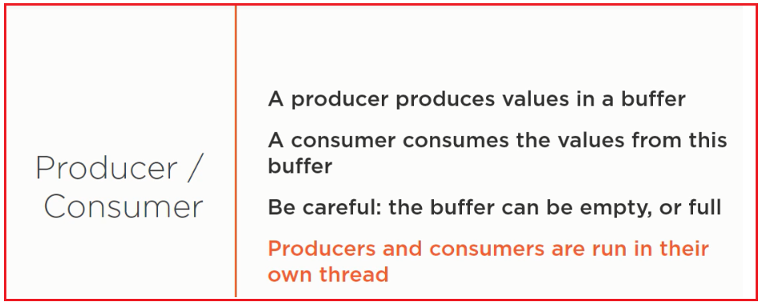

Producer and consumer both run their own thread and they are share basis work over the "Buffer Object" and its subject of Race condition.

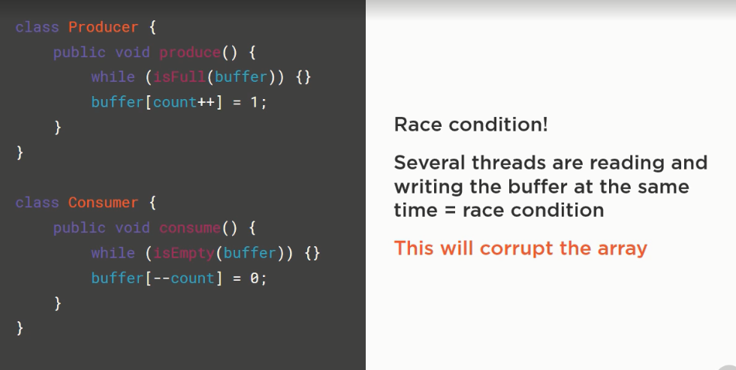

The problem can resolve one way by using synchronized method;

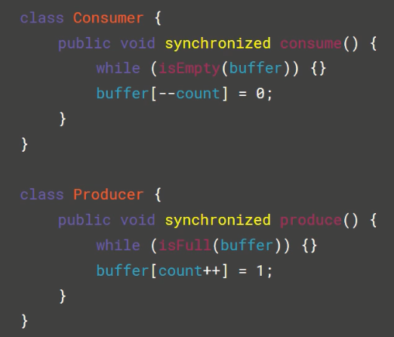

But here the problem is, “lock is either associate with “producer” object or associate with “consumer” object but one lock is not associate with both object.

The perfect solution will be a common synchronization object command to all the instances of “consumer” and “producer”.

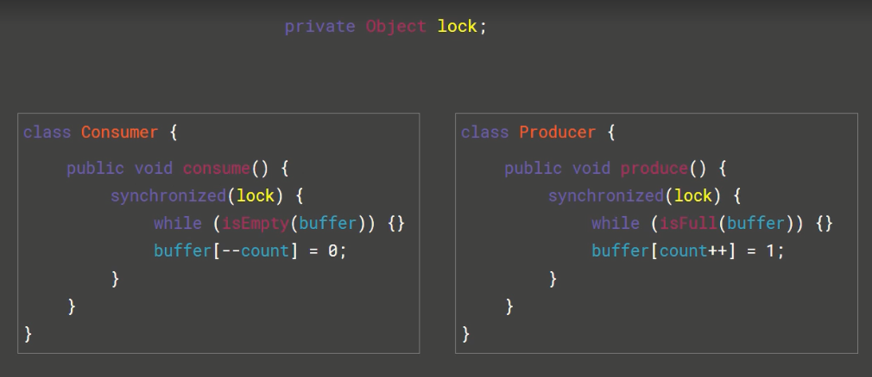

But this approach is also not proper because There is a chance of deadlock.

*One scenario can be when buffer is empty and under synchronization block if at the place ff infinite while loop the lock can be acquired by the thread working on “consumer” object, and the thread which is working over producer thread is waiting for lock.*

**The another way the problem can be resolve by wait-notify() pattern;**

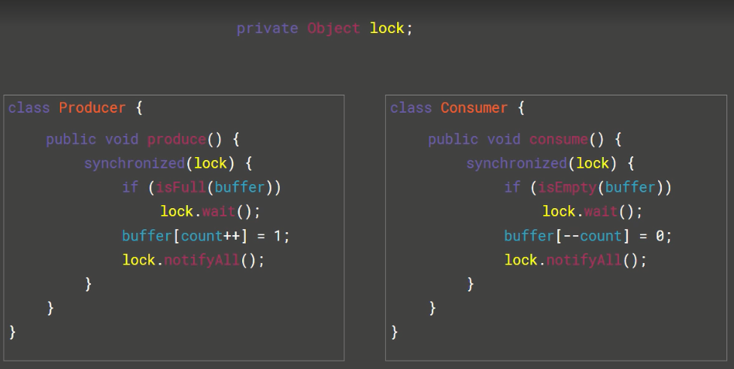

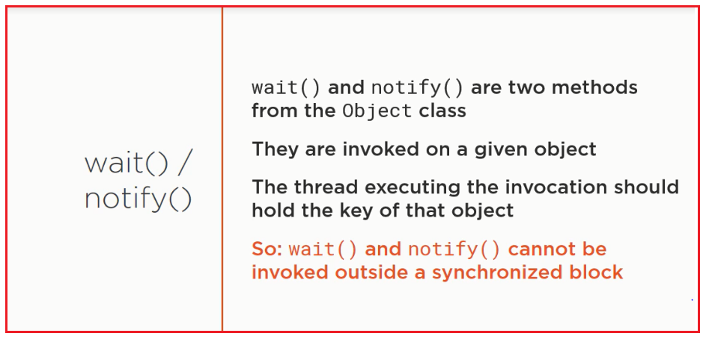

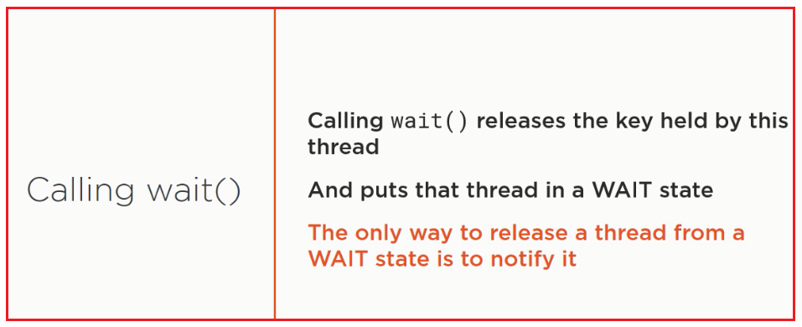

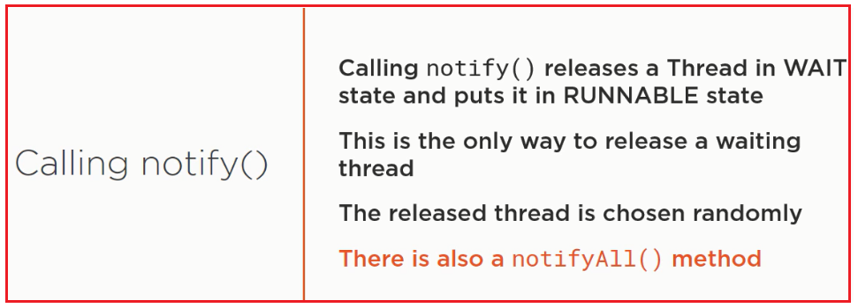

If the queue is empty then consumer thread will call wait() method and entered into waiting state, after producing items to the queue producer thread is responsible to call notify() method then waiting consumer will get that notification and continue its execution., with updated items.

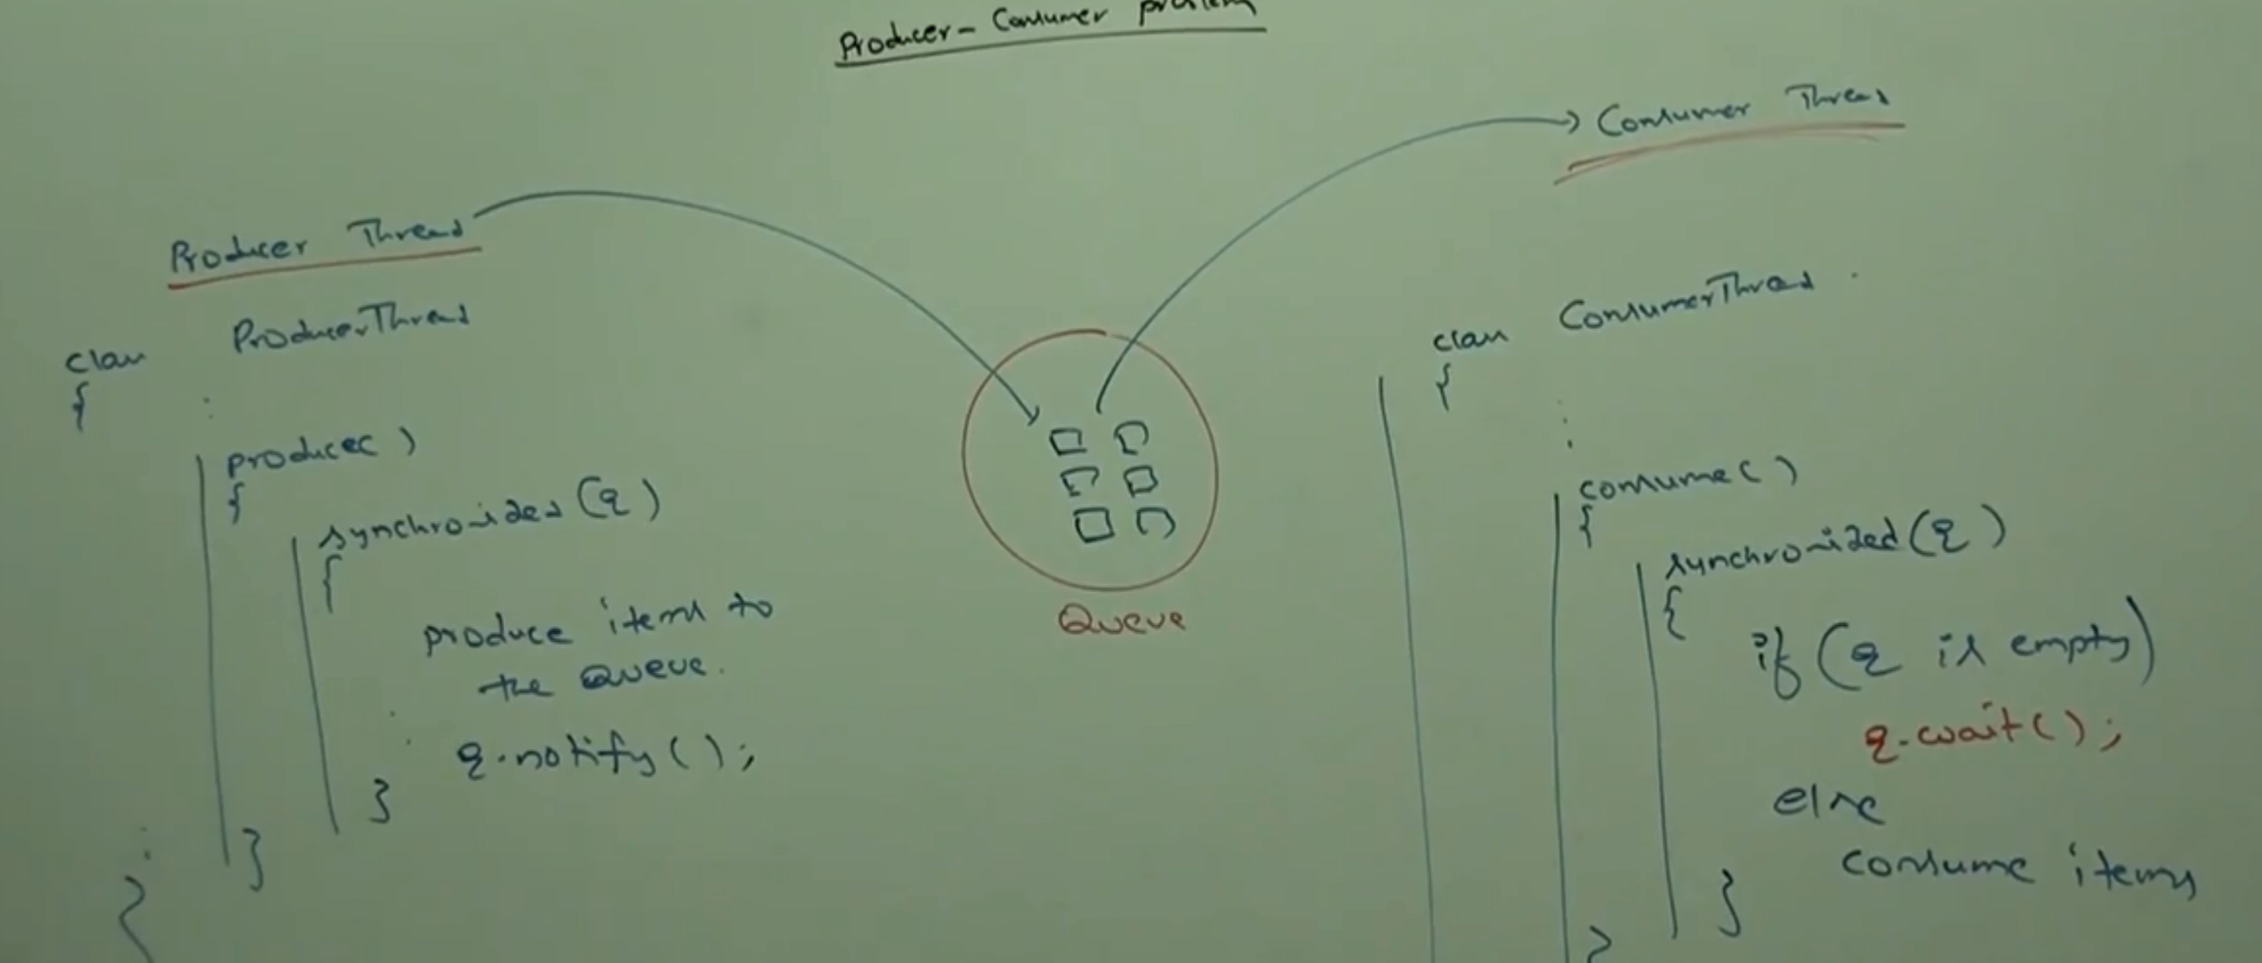

## Difference between notify () and notifyAll()

We can use notify() method to give the notification for only one waiting thread, if multiple threads are waiting then only one thread will be notified and the remaining threads have to wait for further notifications.

Which thread will be notified we can’t expect, it depends on JVM.

We can use notifyAll() to give the notification for all waiting threads of a particular object, even though multiple threads are notified but execution will be performed one by one because threads required lock and only one lock will be available.

And which object we are calling wait() method the thread require the lock of that particular object.

If we are calling wait() method on s1 then we have to get lock of s1 object() but not s2() object.

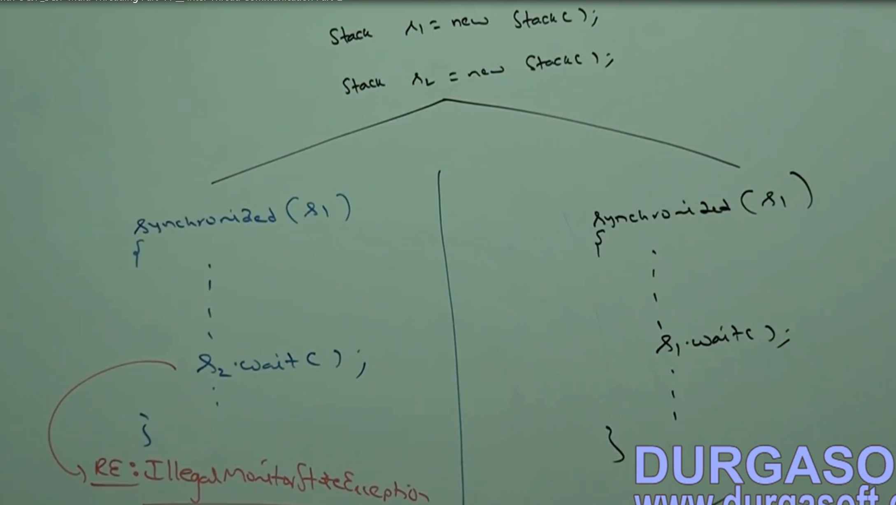

<<part 11 complete>>

# Deadlock :

## Picture:

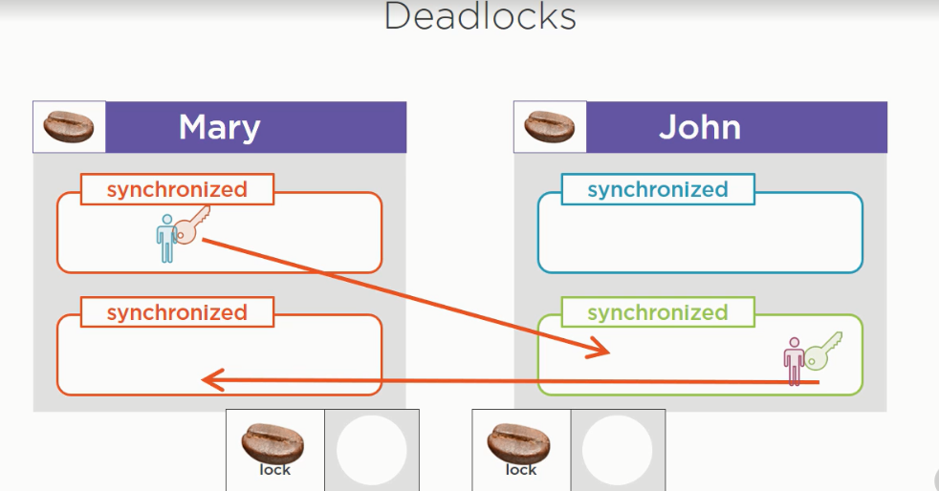

## Property

1. *If two threads are waiting for each other forever such type of infinite waiting is called as Deadlock.*
2. Synchronized key word is the only reason for deadlock situation, hence while using synchronized keyword we have to take special care.
3. There are no resolution technique for deadlock but several prevention techniques are available.

## Example:

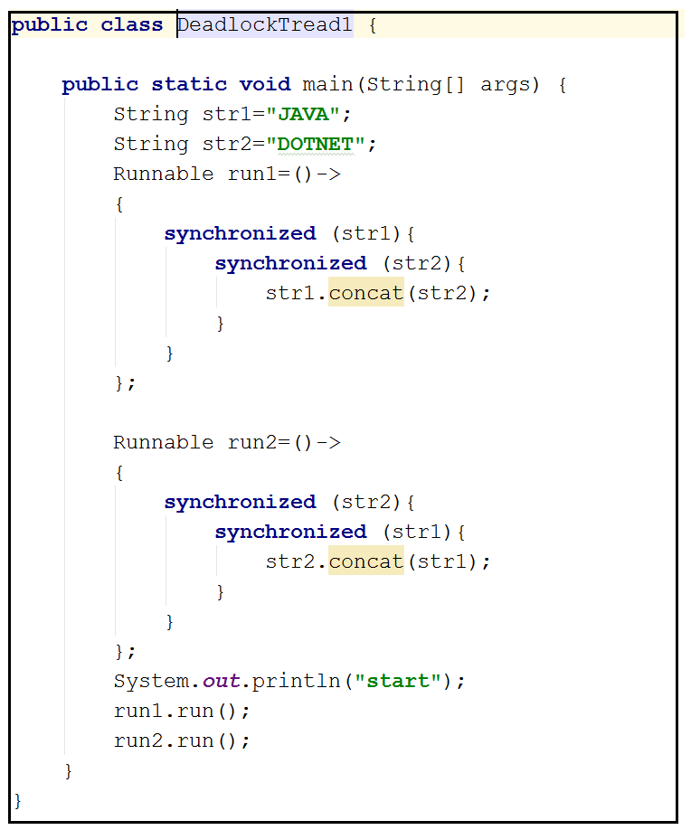

# Deadlock vs Starvation

1. Long waiting of a thread where waiting never ends that type of situation known as Deadlock whereas long waiting of a thread where waiting at a certain time will be end know as starvation.
2. For example of starvation, low priority thread has to wait until completing all high priority threads. It may be long waiting but ends at certain point, which is nothing but starvation.

# Daemon Threads :

1. The threads which are executing at background are known as Daemon Thread.
2. Ex. garbage collector, signal dispatcher, attach listener.
3. The main objective of daemon thread is to provide support for non-daemon thread( main thread) for ex. If main thread runs with low memory them JV runs garbage collector to destroy useless objects so that no. of bytes of free memory will be improved. With this free memory main thread can continue it’s execution.
4. Usually daemon threads having low priority but based on our requirement daemon threads can run with high priority also.
5. Useful methods :
   1. We can check daemon nature of a thread by using isDaemon() method of Thread class.

Public Boolean isDaemon();

* 1. We can change Daemon nature of a thread by using setDaemon() method of thread class:

Public void setDaemon(Boolean b) ;

Note : but changing daemon nature is possible before starting of a thread only. If after starting a thread if we are trying to change daemon nature then we will get RuntimeException saying IllegalThreadStateException();

1. By default main thread is always non daemon and all remaining thread daemon nature will be inherited from parent to child i.e. if the parent thread is daemon then automatically child thread is also daemon and if the parent thread is non daemon then automatically child thread is a.so non daemon.
2. It is impossible to change daemon nature of main thread because already started by JVM at beginning.
3. Whenever las non Daemon thread terminate automatically all daemon threads will be terminated, irrespective of their position.

# Green Thread :

Java multi-threading concept is implemented by using following two models.

1. Green Thread model.
2. Native OS model

**Green** **Thread model** : The thread which is managed completely by JVM without taking underlying OS support is called green thread.

Very Few OS like SUN solaris provide support for green thread model. Anyway green thread model is deprecated and not recommended to use.

**Native OS Model**  : The thread which is managed by the JVM with the help of underlying OS, is called native OS model.

All windows based OS provide support for native OS model.

How to stop a thread?

We can stop a thread execution by using stop() method of Thread class,

Public void stop()

If we call stop() method then immediately the thread will enter into dead state. Anyway stop() method is deprecated and not recommended to use.

How to suspend and resume of a thread?

We can suspend a thread by using suspend() method of thread class, them immediately the thread will be enter into suspended state. We can resume a suspended thread by using resume() method of thread class. Then suspended thread can continue its execution.

Public void suspend()

Public void resume()

Any way this methods are deprecated and not recommended to use.

# Thread group

## Property:

1. Based on functionality we can group threads into a single unit which is nothing but Thread group/ i.e. Thread group contains a group of threads.
2. In addition to threads a thread group can also contain sub thread groups.
3. The main advantage of maintaining threads in the form of Thread group is we can perform common operation very easily.
4. Every thread in java belongs to some thread. Main Thread belongs to main group;
5. Every thread group in java is child group of System group either directly or indirectly, hence System group access root for all thread groups in java.
6. System groups contain several system level threads like
   1. Finalizer
   2. Reference handler
   3. Signal dispatcher
   4. Attach Listener

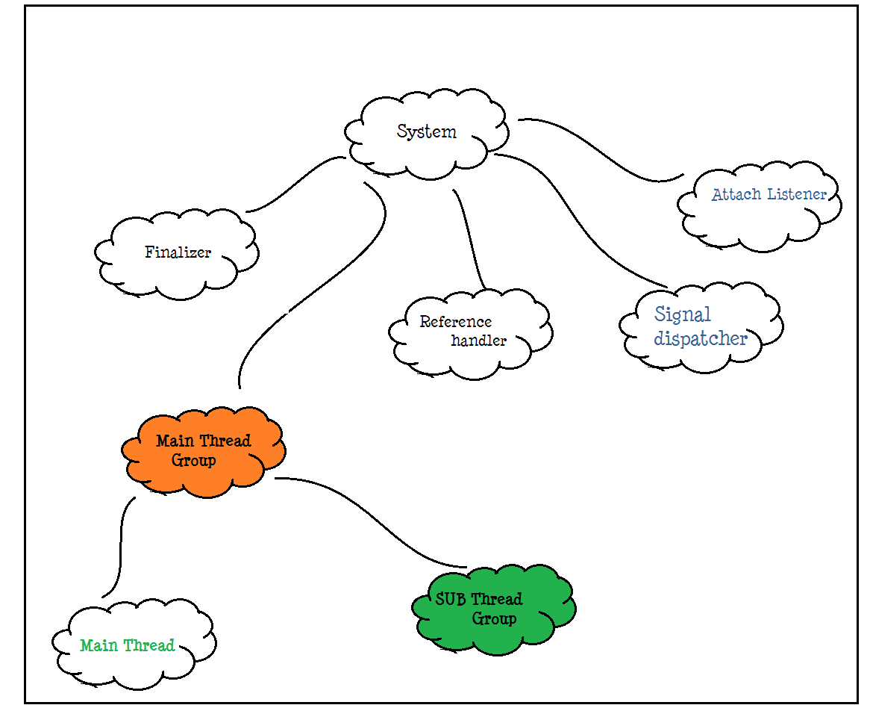

1. We can get ThreadGroup reference from main thread and its parent thread like this way :



1. Thread group is a java class present in java.lang package and it is the direct child class of object.

## Hierarchy :

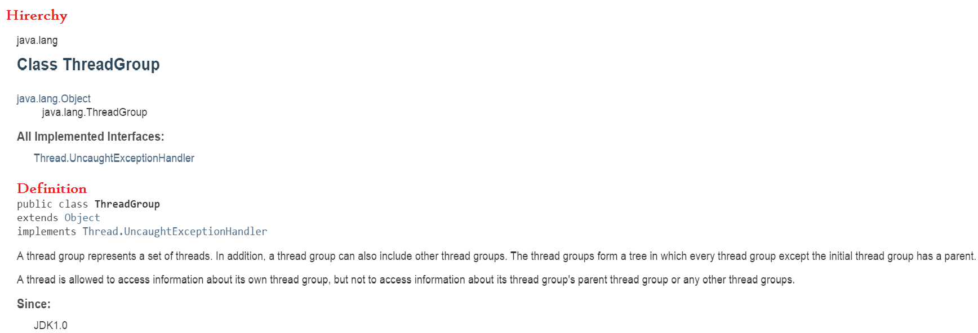

## Constructor :

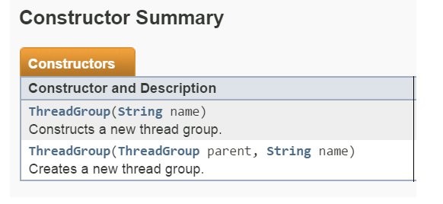

### Constructor Type 1:

#### Signature



#### Property

Creates a new ThreadGroup with the specified group name. “first Group”

#### Diagram:

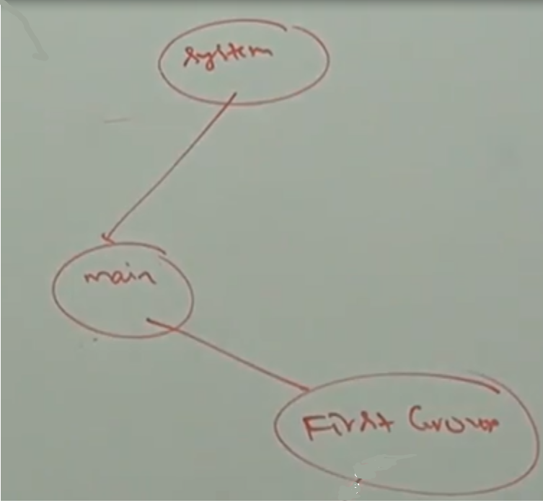

### Constructor Type 2

#### Signature



#### Property

* Creates a new ThreadGroup with the specified group name. **“Second Group”**
* The parent of new thread group is specified parent group which is **“First Group”**

#### Diagram :

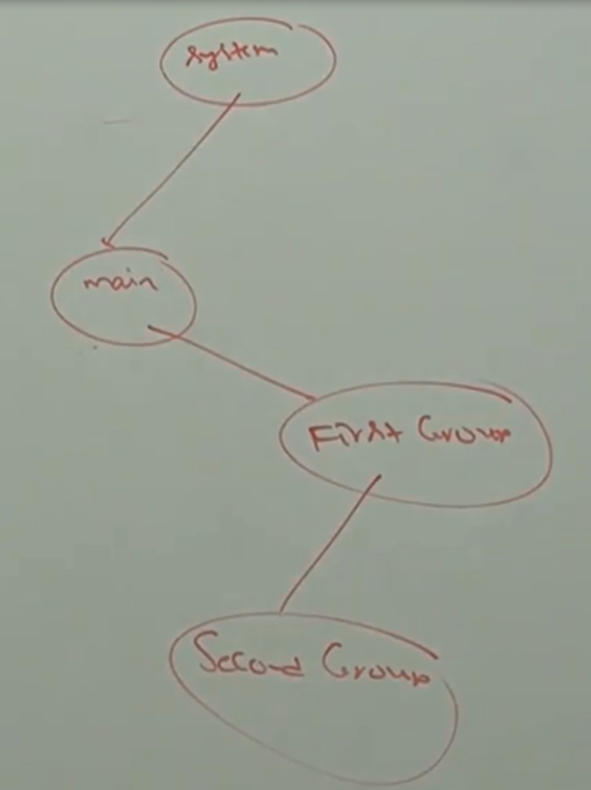

### Constructor Example :

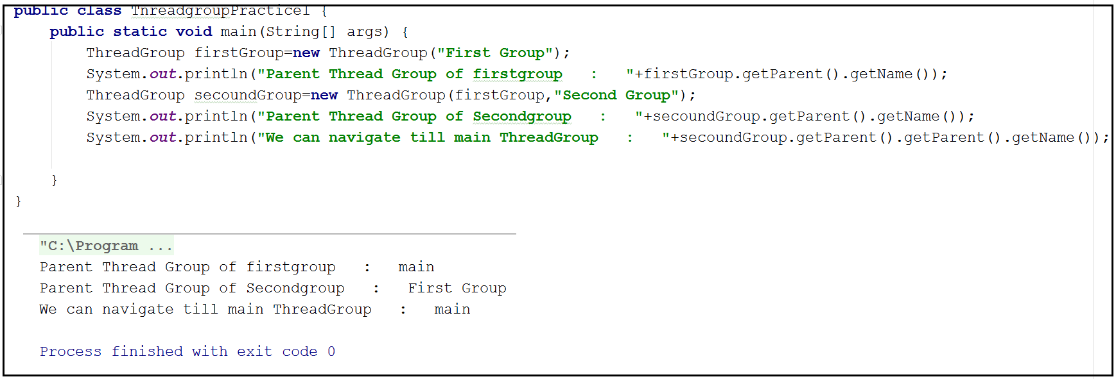

<<WILL BEADDED CODE>>>

## Important Methods:

|  |  |  |
| --- | --- | --- |
| **1** | **String getName()** | Returns name of the ThreadGroup(); |
| **2** | **int getmaxPriority()** | Returns maximum priority of Thread Group(). |
| **3** | **void setMaxPriority(int p)** | To set maximum priority of Thread group.  [ The default max. priority is 10]. |
| **4** | **ThreadGroup getparent()** | Returns parent group of current Thread. |
| **5** | **void list()** | ThreadGroup having list() methiod which prints information about thread group in console. |
| **6** | **int activeCount()** | Returns no. of active Threads Present in the Thread group. |
| **7** | **Int activegroupCount()** | It returns no. of active groups present in the current thread group |
| **8** | **int enumerate(Thread [] t)** | To copy all active threads in a thread group into provided thread array. In this case sub thread groups Thread also will be considered. |
| **9** | **int enumerate(ThreadGroup[] g)** | To copy all active sub-thread groups into Thread group array |
| **10** | **boolean isDaemon()** | To check whether a Thread Group is Demon Thread or no |
| **11** | **Void setDaemon(Boolean b)** | To change a daemon nature of a thread. |
| **12** | **void interrupt () :** | To interrupt all waiting and sleeping thread present in the thread group. |
| **13** | **void destroy()** | To destroy thread group and its sub thread groups. |

## CASE STUDIES

### Case Study1 :

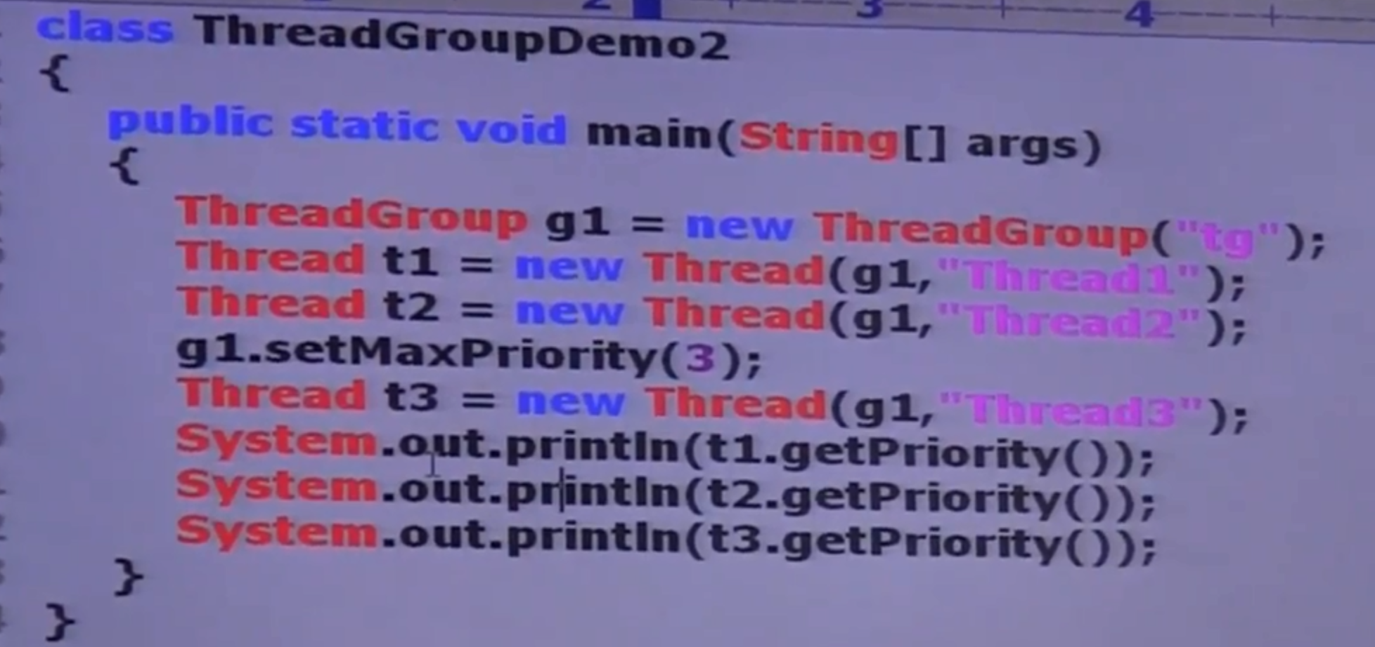

**Here t1 & t2 priority will be 5 whereas t3 is 3.**

Note:

Threads in the thread group that have already higher priority won’t be affected but for newly added thread this max priority is applicable.

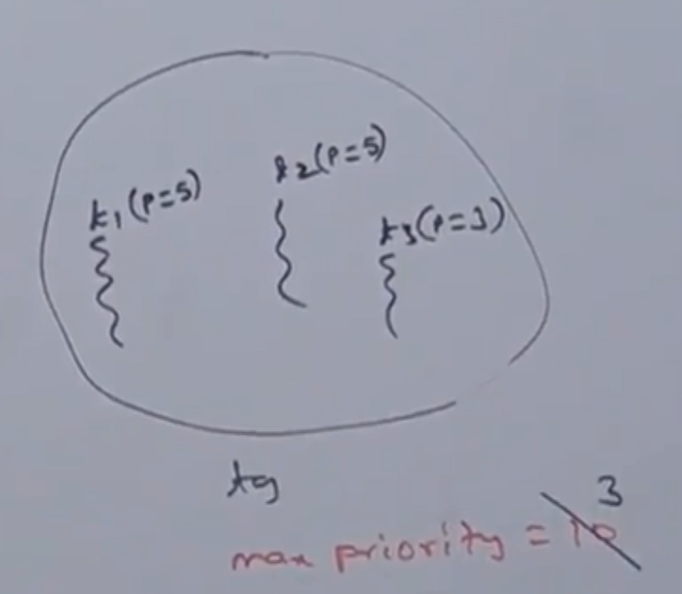

### Case Study 2:

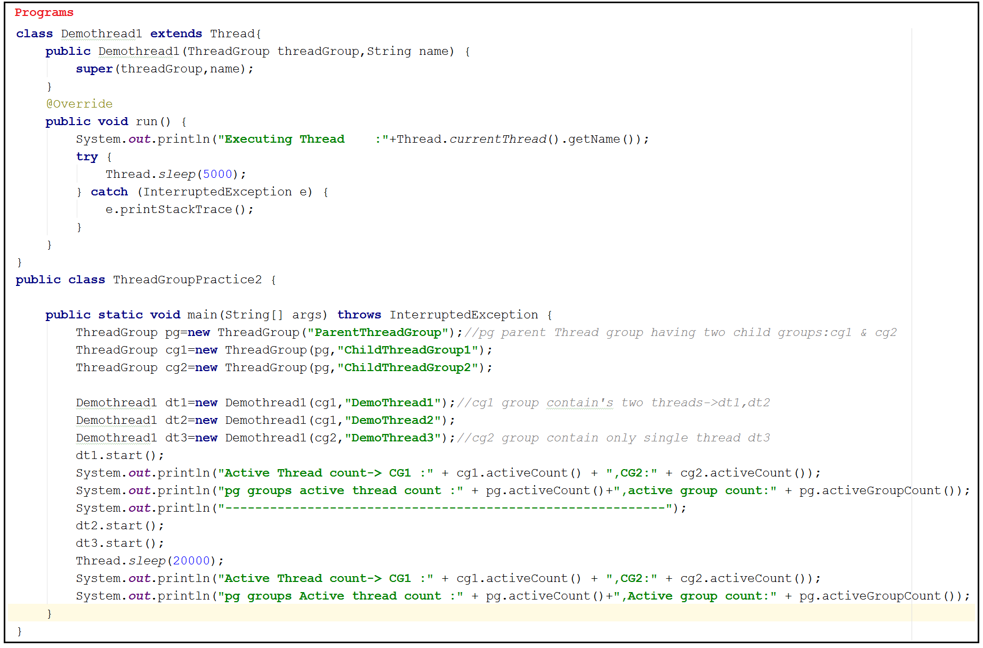

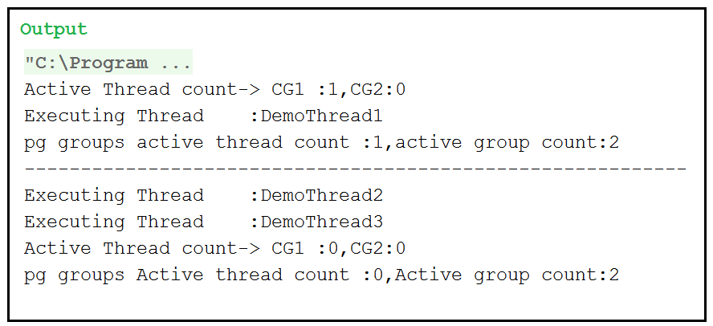

### Case Study 3

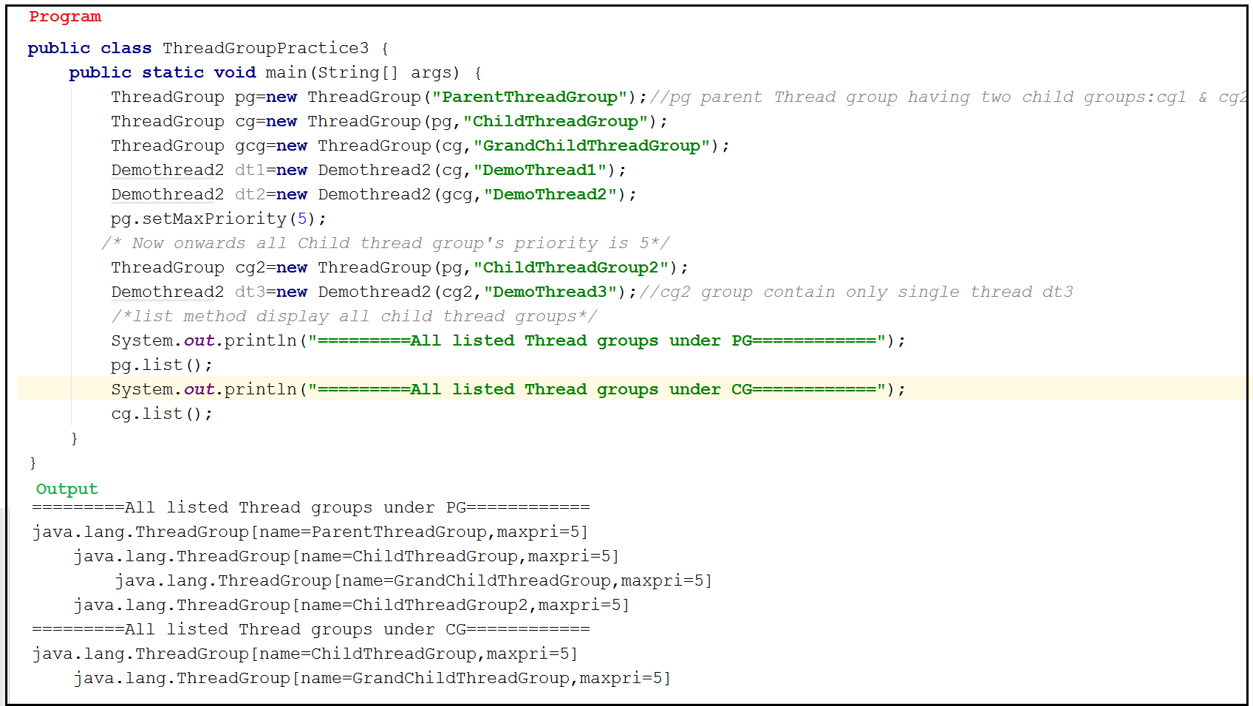

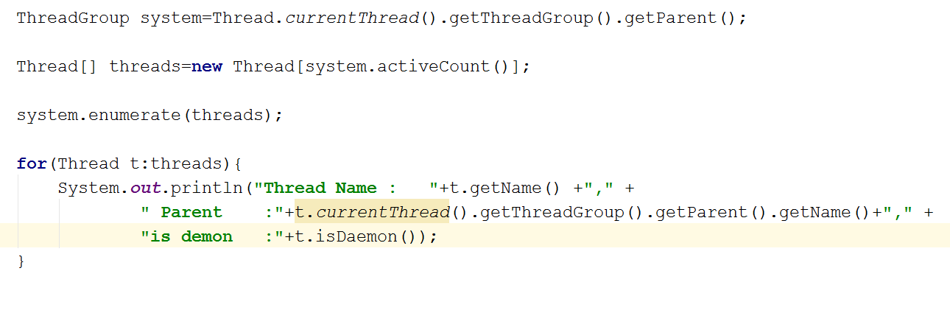

### Case study 4

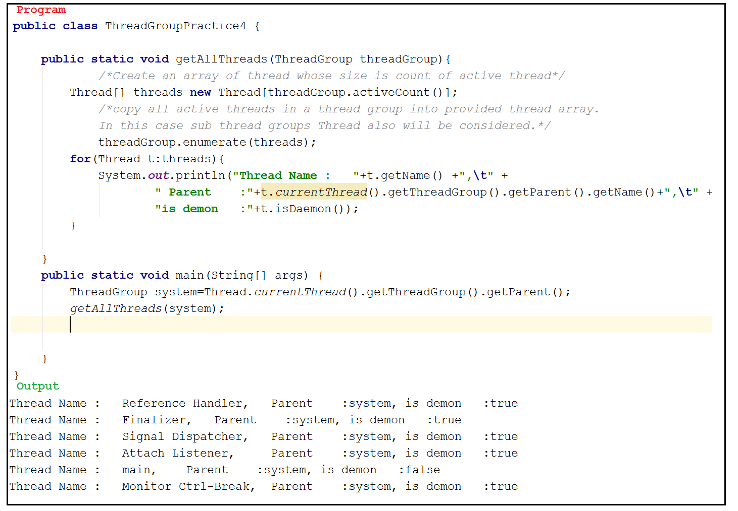

# Java,util,concurrency packages:

## Synchronized Problems

The problems with traditional SYNCHRONIZED key word:

1. We are not having any flexibility to try for a lock without waiting.
2. There is no way to specify maximum waiting time for a thread to get lock so that Thread will wait until getting the lock which may create performance problem, which may cause dead lock.
3. If a thread release a lock then which waiting thread will get that lock we are not having any control on this.
4. There is no API to list out all waiting thread for a lock.
5. The synchronized keyword compulsory we have to use either at method level or within the method as synchronized block, and it’s not possible to use across multiple methods.

## Problem Resolutions

* To overcome these problems, Sun has introduced **java.util.concurrent.**locks package in java 1.5 version.
* This package also provide several enhancements to the programmer to provide more control over concurrency.

If the thread is inside a synchronized block and have some problem, unable to release the lock, then another threads having no other way we except waiting.

There the control over threads are really less- here the reason of locking started.

# Lock interface() :

## Hierarchy:

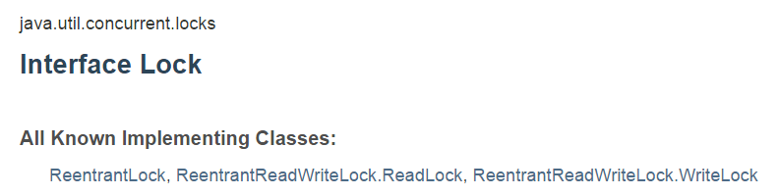

## Properties:

1. Lock object is similar to implicit lock acquired by a thread to execute Synchronized method or Synchronized block.
2. Lock implementation provides more extensive operations than traditional implicit locks.

## Methods:

|  |  |  |
| --- | --- | --- |
| 1 | **void lock()** | * We can use this method to acquire a lock. If the lock is already available then immediately current thread will get that lock. * If that lock is already available then it will wait until getting the lock. * It is exactly same behaviour of traditional Synchronized Keyword |
| 2 | **boolean tryLock()** | * Try to acquire the lock without waiting ; * If the lock is available then the tread acquire the locks and returns true * If the lock is not available then this method returns false and continue its execution without waiting. * In this case thread never be enter into waiting state.   if(l.trylock()){  //perform safe operation;  }else{  //alternating operation;  } |
| 3 | **boolean tryLock(long time, TimeUnit unit)** | * If lock is available then the thread will get the lock and continue its execution. * And if lock is not available then thread will wait until specified amount of time and still if lock is not available then thread can continue its execution.   NOTE : TimeUnit is an ENUM present in java.util.concurrent package.  enum TimeUnit(){  Nanoseconds, microseconds, milliseconds, seconds, minutes, hours, days  } |
| 4 | **void lockInturruptably()** | * Acquires the lock if it is available and returns immediately. * If the lock is not available then it will wait. While waiting if the thread is interrupted then Thread won’t get the lock. |
| 5 | **void unlock()** | * To release the lock. * To call this method compulsory current thread should be owner of this lock otherwise we will get *RuntimeException* saying **IllegalMonitorStateException**. |

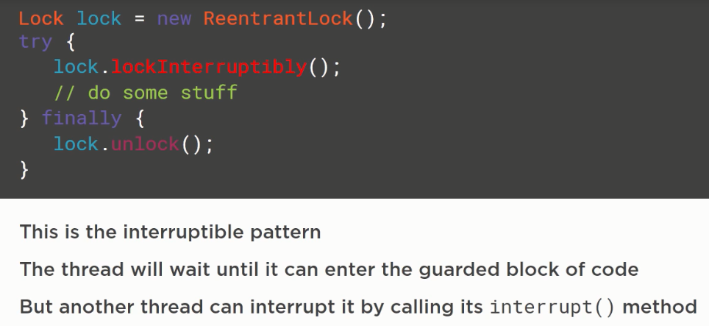

Note:

All available constants are:

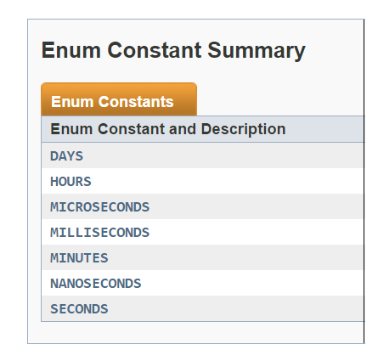

# ReentrantLock:

## Hierarchy

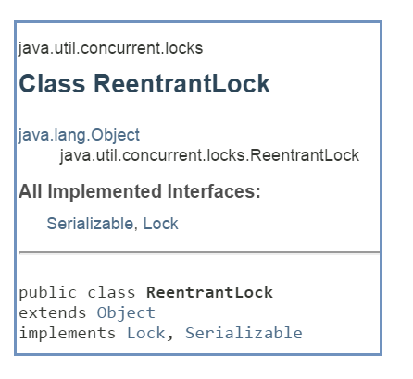

## Property

1. It is the implementation class of lock interface and it is the direct child class of object.
2. **“Re-entrant”** means a thread can acquire. **It is increments threads personal count whenever we call lock method and decrements count value whenever thread calls unlock method** and lock will be release whenever count reaches 0.

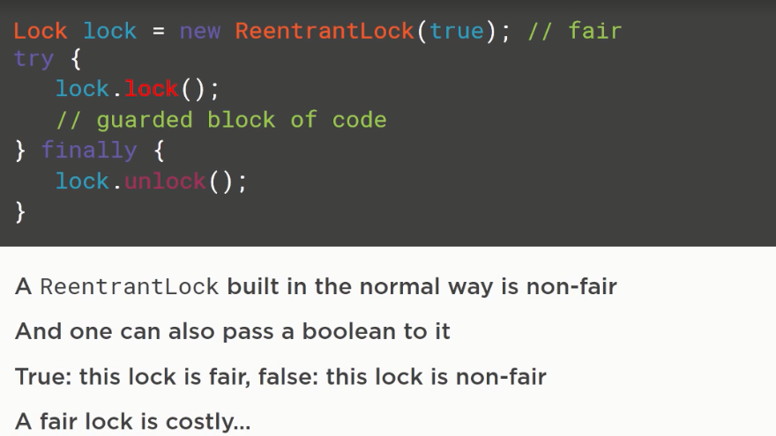

Note:

For every lock JVM maintains a hold count.

## Constructors :

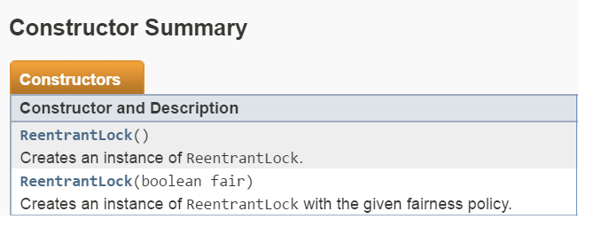

### Constructor 1:

ReentrantLock rl1=**new** ReentrantLock();// fairness policy false

[ Here default fairness value is false ]

Constructor 2:  
ReentrantLock r2l=**new** ReentrantLock(**true**);//fairness policy is true

* This Second constructor given re-entrant lock with given fairness policy.
* If the fairness is true then longest waiting thread can acquire the lock if it is available, that is it follows First-Come-First-Serve policy.

## Q&A

If Fairness is false then which waiting thread will get the chance we can’t expect?

For First constructor default value is false.

Which of the following declarations are equal?

:

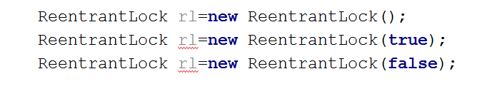

Here First one and third one are same

## Important Methods

: As this class is implemented Lock interface all methods are available here:

|  |  |  |
| --- | --- | --- |
| 1 | **Int getHoldCount()** | Returns no. of holds on this lock by current thread |
| 2 | **Boolean isHeldByCurrentThread()** | Returns true if and only if lock is hold by current thread. |
| 3 | **int getQueueLength()** | Returns no of threads waiting for the lock |
| 4 | **Collection getQueuedThread()** | It returns a collection of threads which are waiting to get the lock |
| 5 | **boolean hasQueuedThreads()** | Returns true if any thread waiting to get lock |
| 6 | **boolean isLocked()** | Returns true if the lock is acquired by same thread. |
| 7 | **Boolean isFair()** | Returns true if the fairness policy is set with true value. |
| 8 | **Thread getOwner()** | Returns the thread which acquires the lock |

## Program:

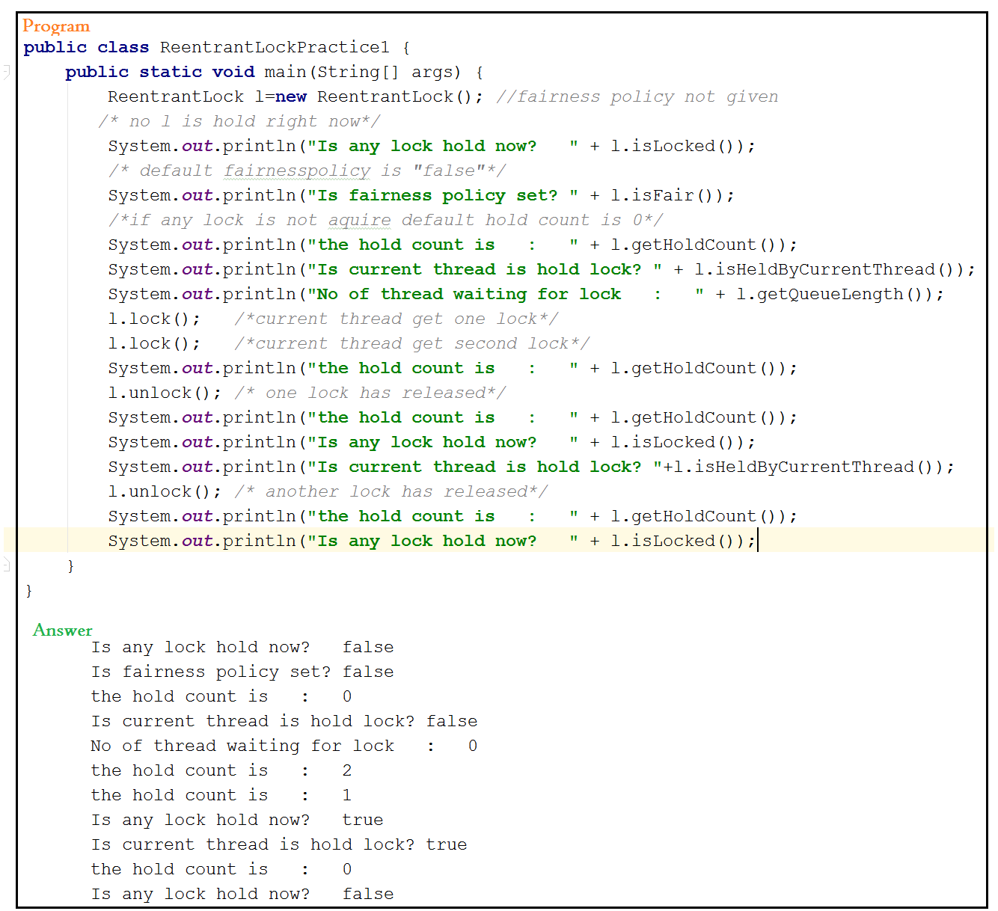

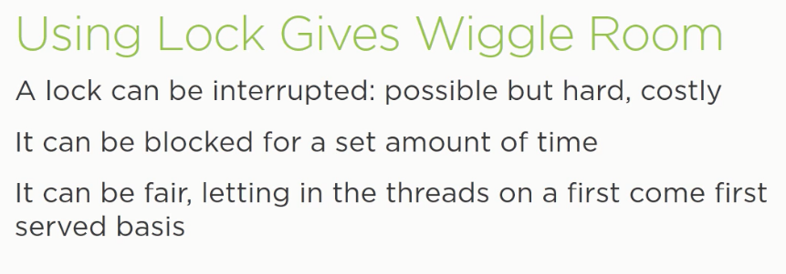

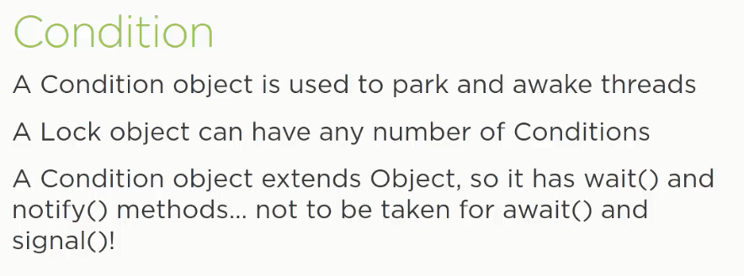

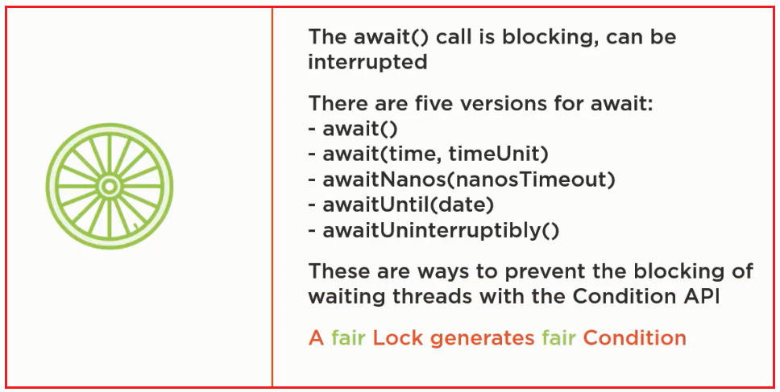’

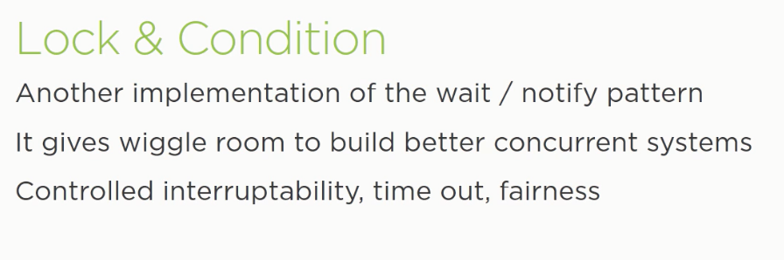

## Situation Studies

### Situation 1

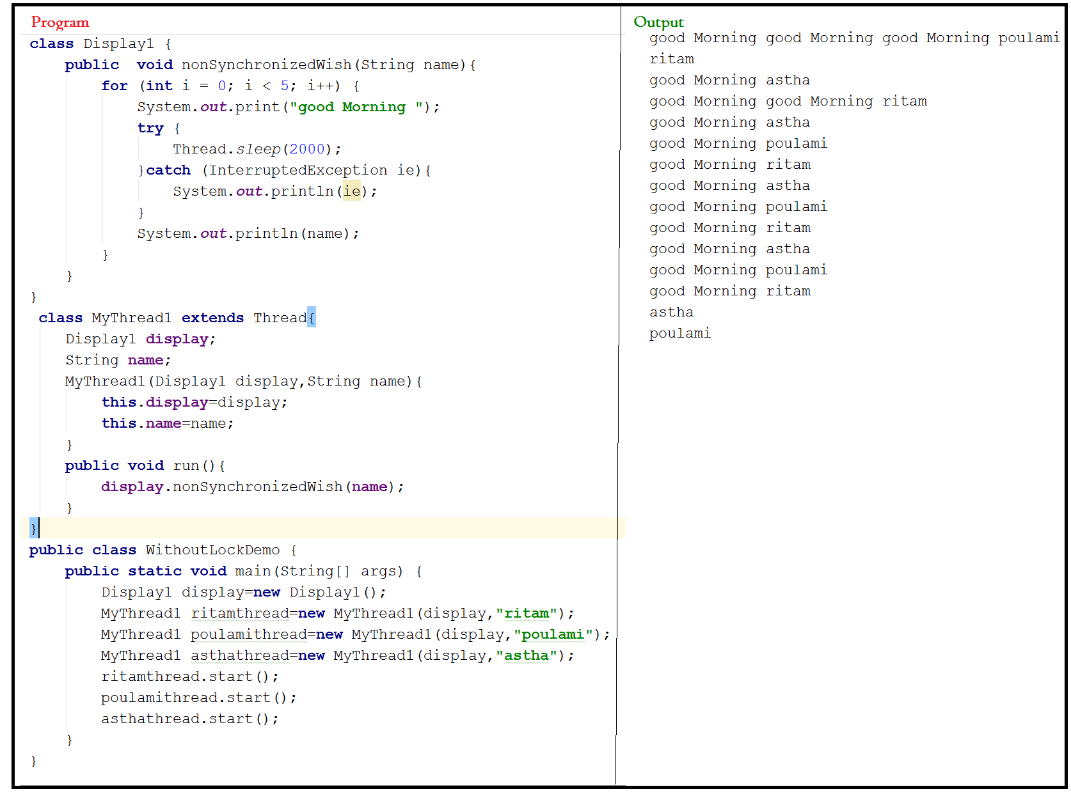

### Situation 2:

1. In this situation to get regular output we use synchronized method.
2. Here which thread will execute that is not sure, but once a thread get chance to execute it keep lock until execution of that thread is over.

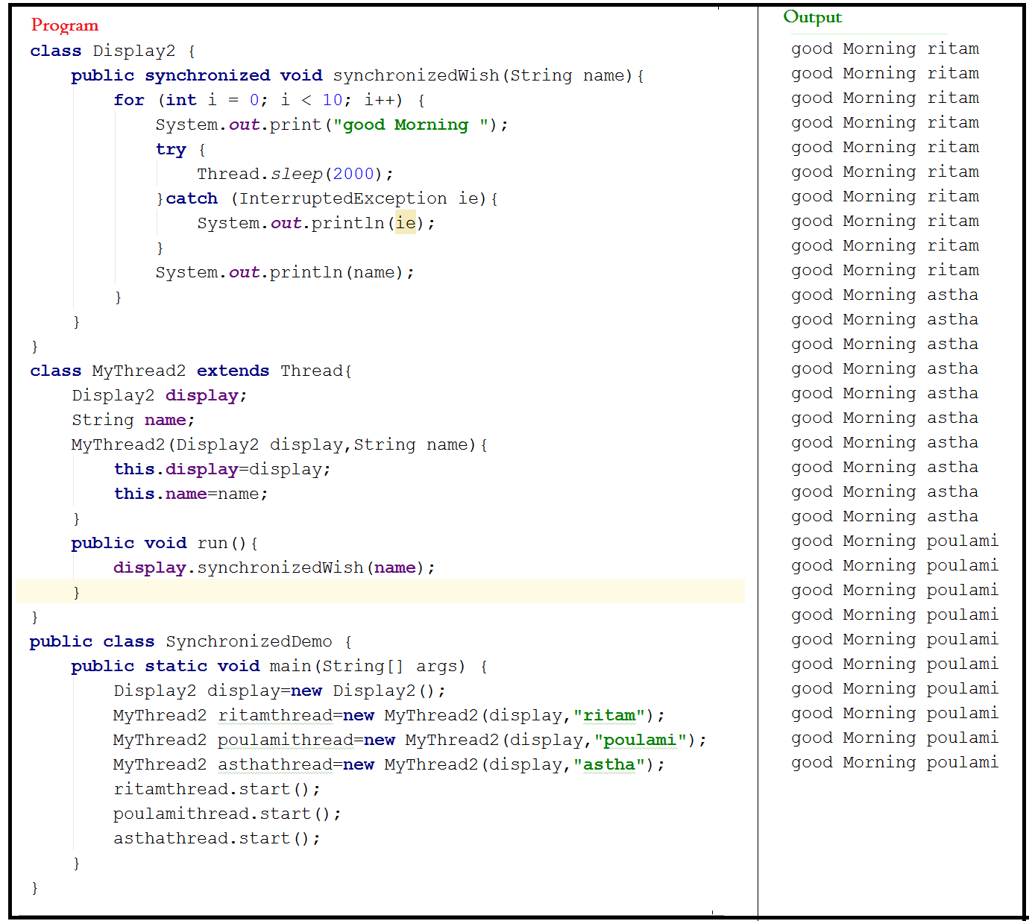

### Situation 3:

1. Here to maintain regular output we use lock.
2. We are not making thread safe entire method rather than particular portion which we are willing to make thread safe.

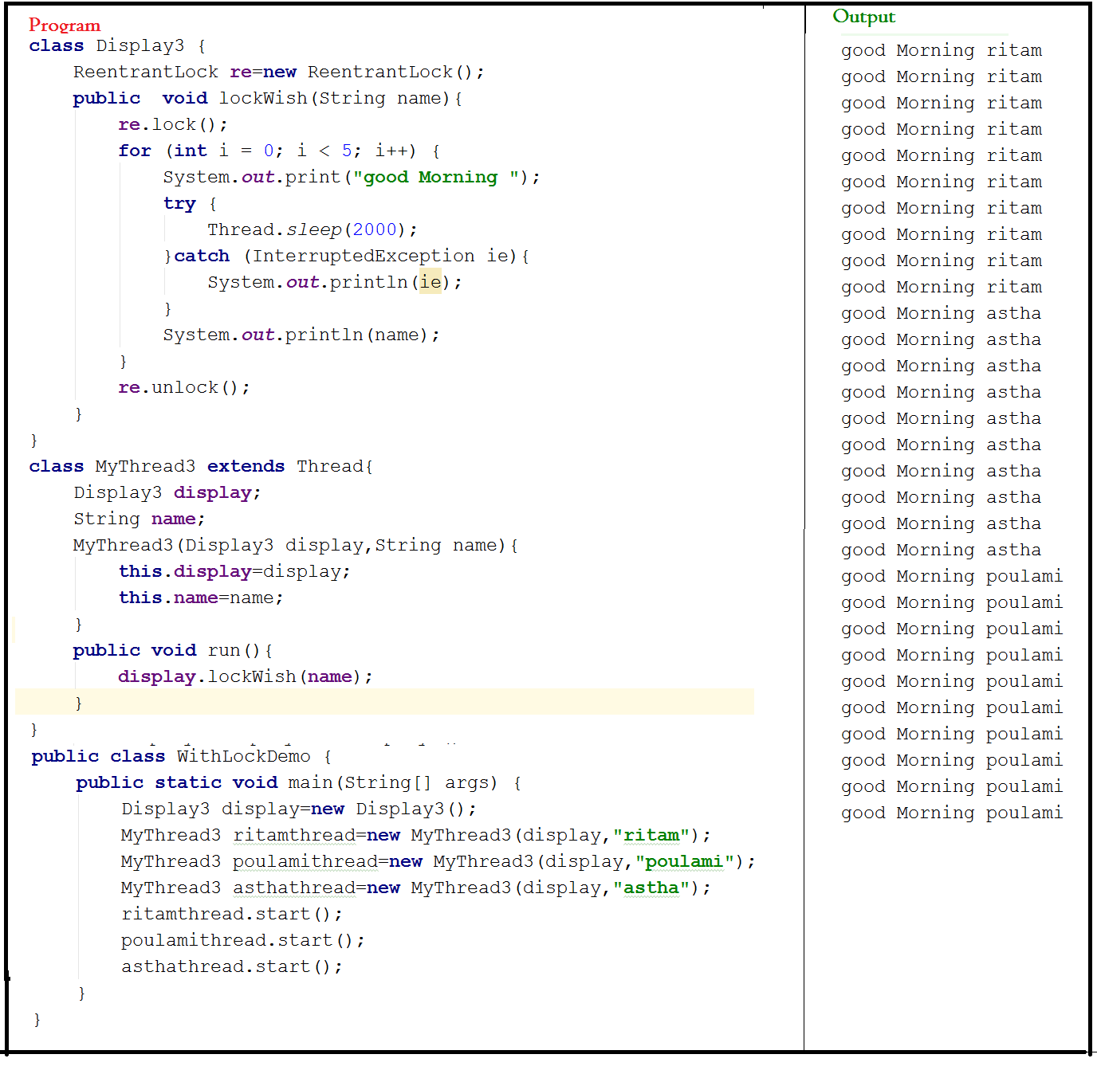

* If we comment the line “re.lock()” and line “re,lock()” then thread will execute simultaneously and we will get irregular output.
* If we are not comment these line then the tread will be executed one by one and we will get regular output.

### Situation 4

* In this program lock should be unique so we will use static Re-entrant lock;
* Here Either first Thread get chance and execute or second thread will get chance and execute, but simultaneously both will not execute.
* Here one thread will do safe operation or alternate operation.
* In this case thread never enters into waiting state.

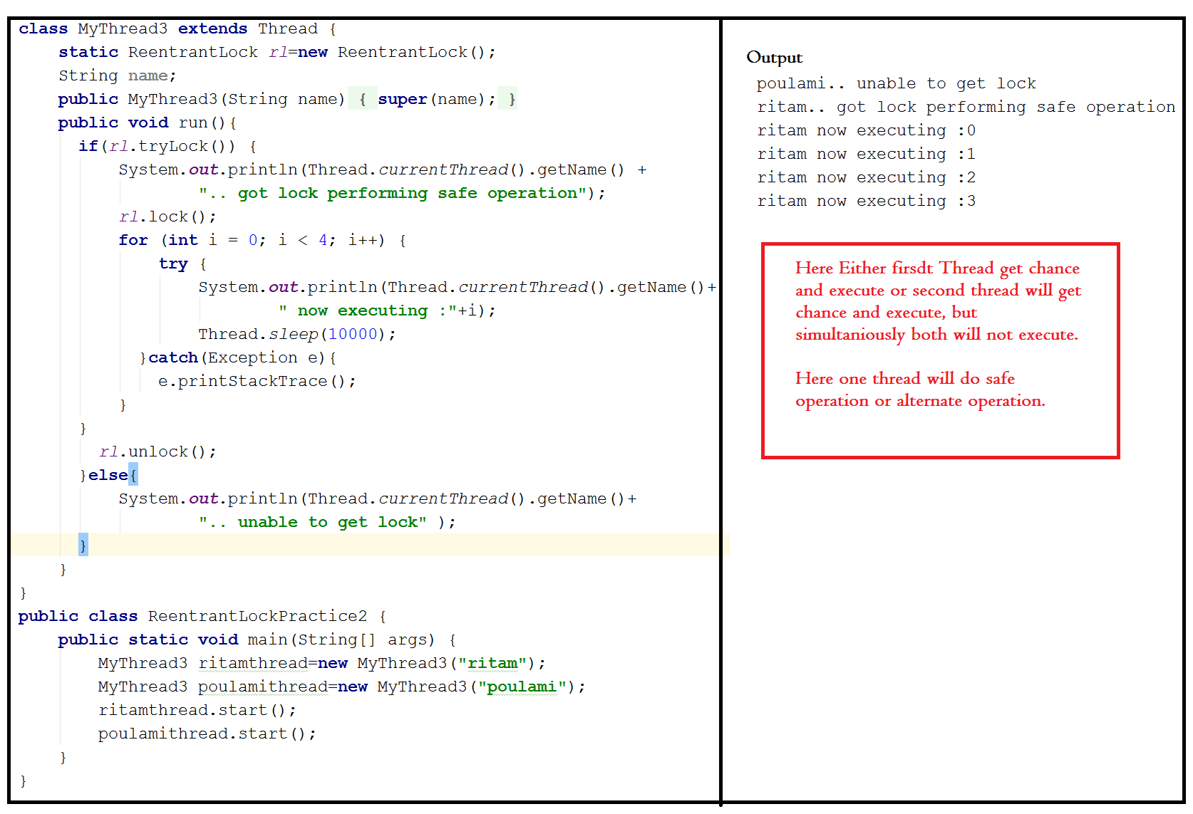

### Situation 5

Here we can implement try lock by using lambda expression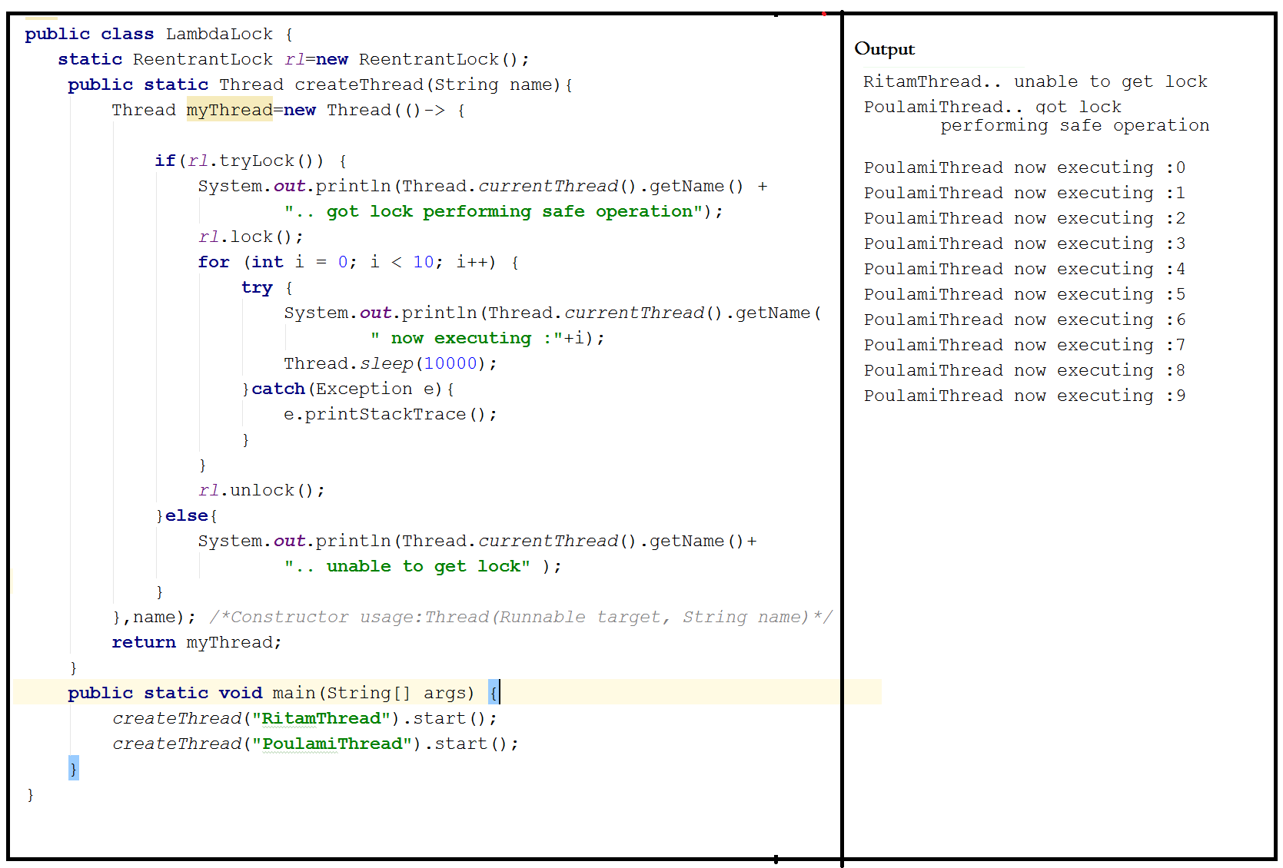

### Situation 6

The one thread will get lock and do safer operation.

Another thread which not able to get lock immediately not do alternate operation rather it wait for some time and once that time over then do safest operation.

# 

# Thread Pools :

Necessity:

**Thread creates on demand:**

The classical approach of creating a thread is problematic, and that is when developer creates new thread freely according to their need, there they might end up thousands of threads, created throughout the application by them, killing it.

Though once the thread is created it must be die, but thread is an expensive resource, and intervention of underlying OS needed at high scale which too expensive resource and involve OS to create thread and kill that is high paying cost.

So though this approach works perfect, but technical points of view it’s not acceptable.

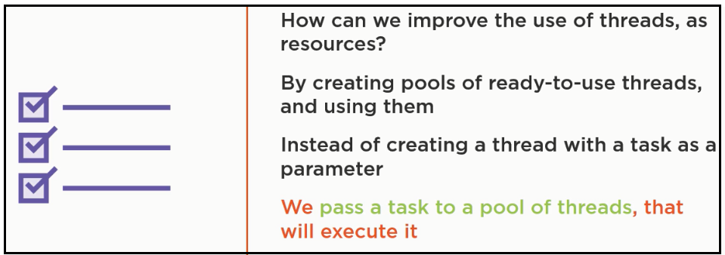

*Creating a new thread for every job may create performance and memory problem. To overcome this we should go for Thread Pool pattern.*

The Thread-Pool Pattern

1. Creates a pool of threads

2. And pass the task into that pool of Thread.

**Thread pool is a pool of already created threads ready to do our job.**

Java 1.5 version introduces ThreadPool framework to implement thread pools. Thread Pool framework also known as executor framework.

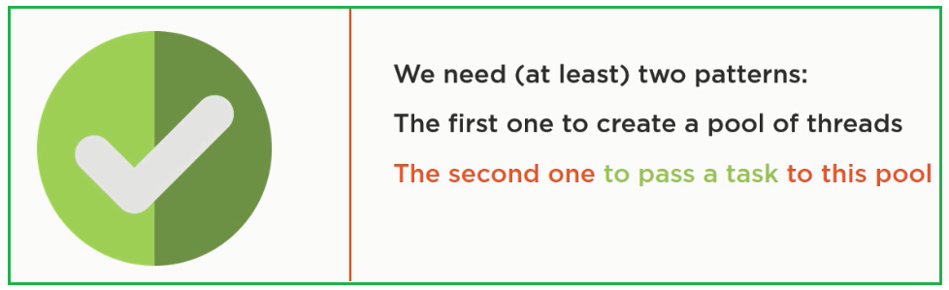

A pool of thread is an instance of "Executor" interface;

Executor interface having only one method "execute' which takes a "runnable" task;

A pool of thread is an instance of "Executor" interface;

Executor interface having only one method "execute' which takes a "runnable" task;

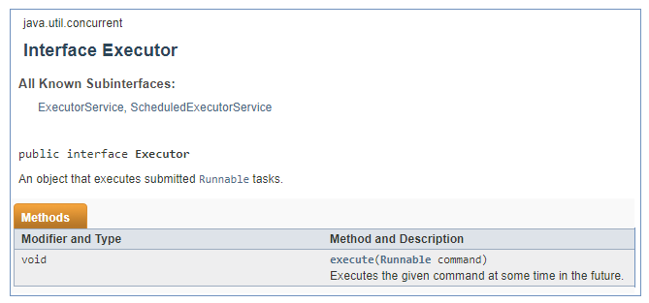

There is another interface "ExecutorService" which extends "Executor".

All API level implementation of “Execuor” are also implemented in "ExecutorService" as it is an extension of "Executor"

Additionally it has 20 more methods.

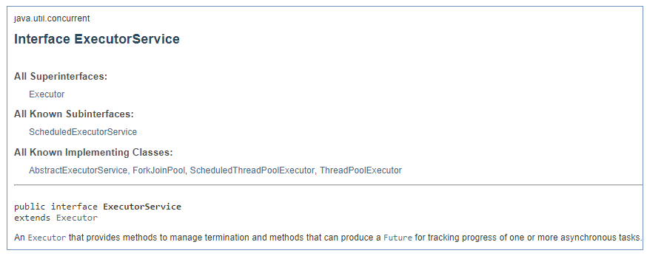

To create instances of those implementations, we have a factory class "Executors".

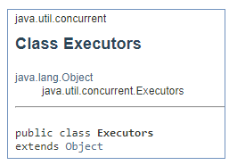

Two most used executors are

1. Single Thread Executor

2. Fixed Thread Pool Executor;

3. Cached Thread Pool Executor;

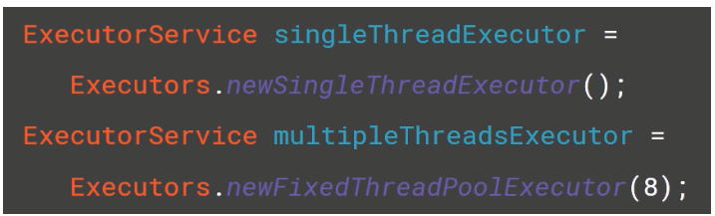

In executor services all tasks are added into waiting queue and tasks are executed in the order they have added.

Note:

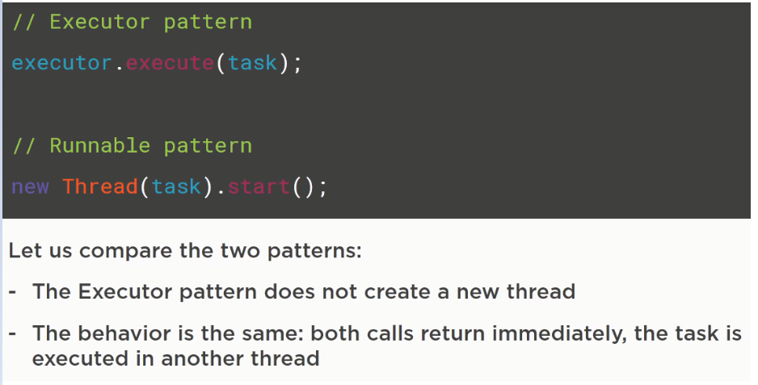

## Property

* We can create a Thread Pool as follows :

ExecutorService service= Executors.*newFixedThreadPool*(5);

* We can submit a runnable job by using submit methods.

Example:

service.submit(**new** Runnable() {  
 @Override  
 **public void** run() {  
 **for** (**int** i = 0; i < 5; i++) {  
 System.***out***.println(**"Value of i"**+i);  
 }  
  
 }  
});

* Once that done we have to shut down the service by using shutdown() method:

service.shutdown();

* While developing web server or application server we can use thread pool concepts.

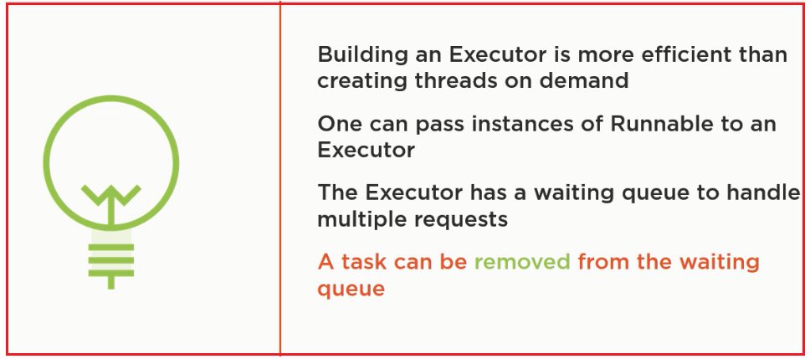

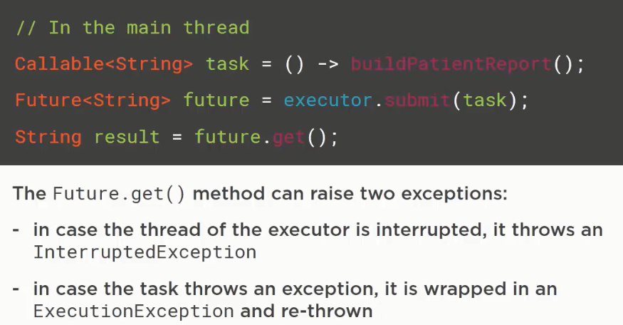

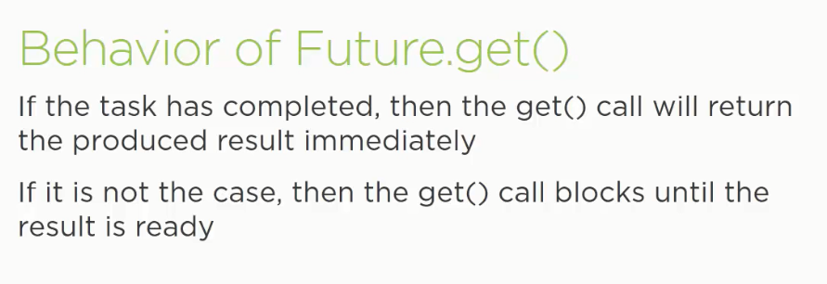

creats threads on demand, keep those unused threads alive for 60s, then terminates them.

After using of executor shutdown that at finally block is recommended.

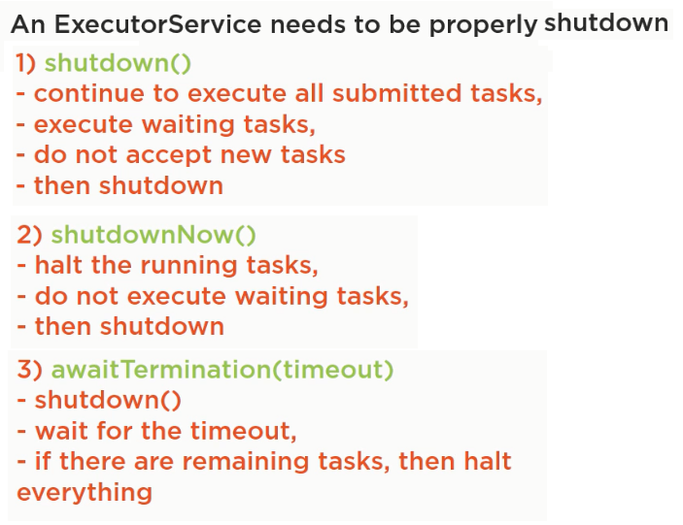

## Case Studies

### Scenario 1:

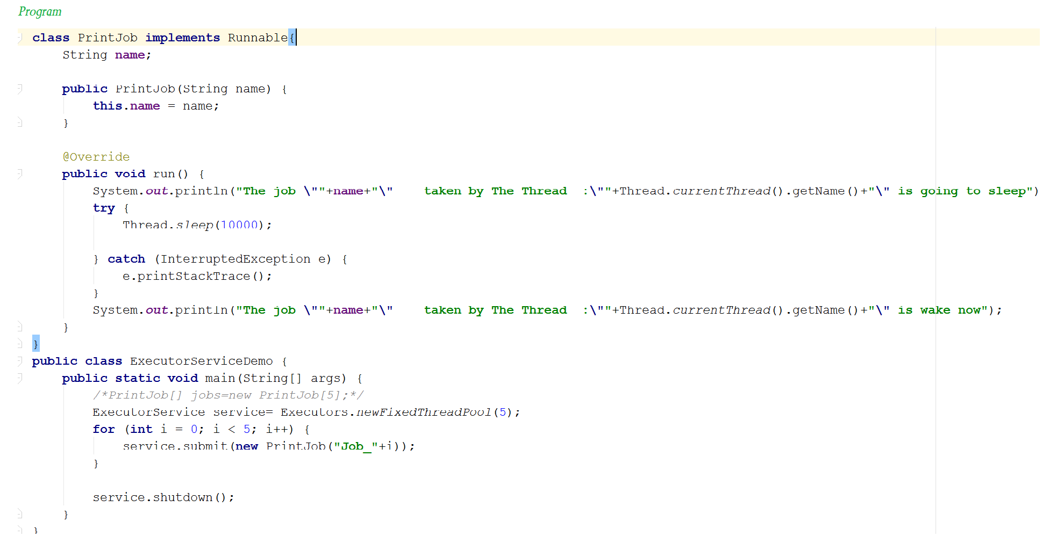

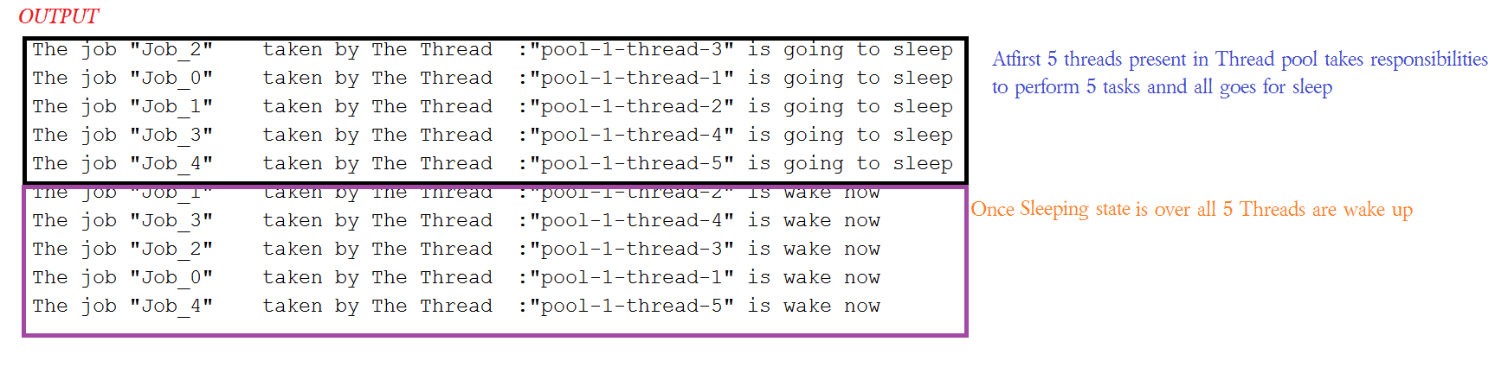

### Scenario 2:

Now we keeping 3 Threads at Thread Pool and we can check change in output.

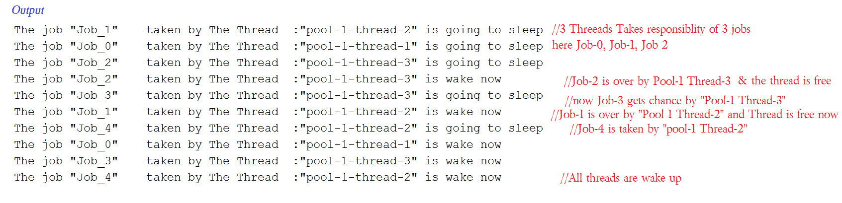

In the above example Three Threads are responsible to execute 5 Jobs so that an single thread can be reused for multiple jobs (here two Threads responsible for 2 jobs and 1 thread responsible for 1 Jobs)

Scenario 3: Thread Pool has two threads only;

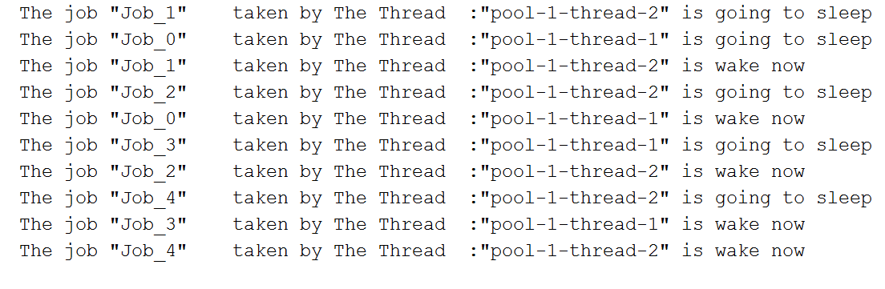

Note:

While designing web Servers & Application servers we can use “thread Pool” concept and default size is 60.

# Callable and Future :

## Callable:

In the case of Runnable job Thread won’t return anything after completing the job, **if a thread is required to return some result after execution then we should go for callable.**

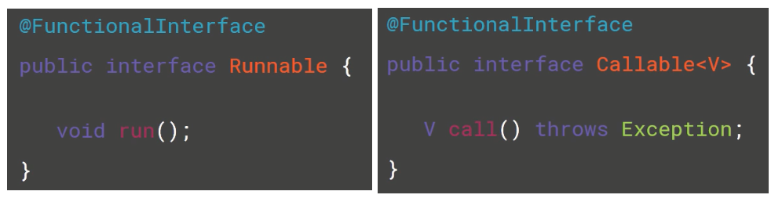

### API Design

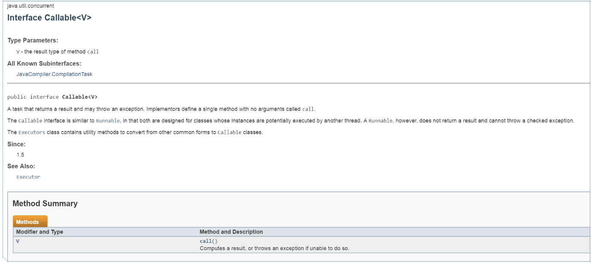

## Future:

**If we submit a callable statement to executor then after completing the job Thread returns an object of type “Future” i.e. Future object can be used to retrieve the result from callable job.**

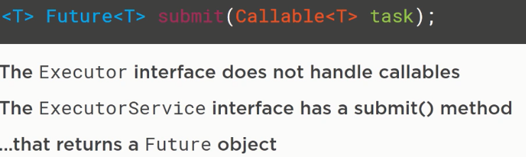

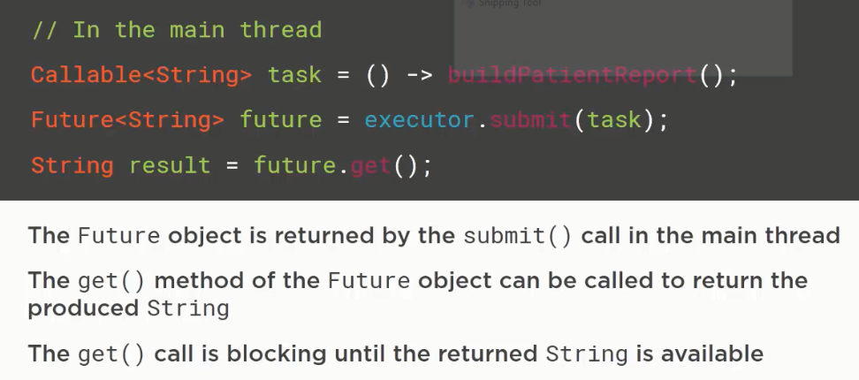

## Programs:

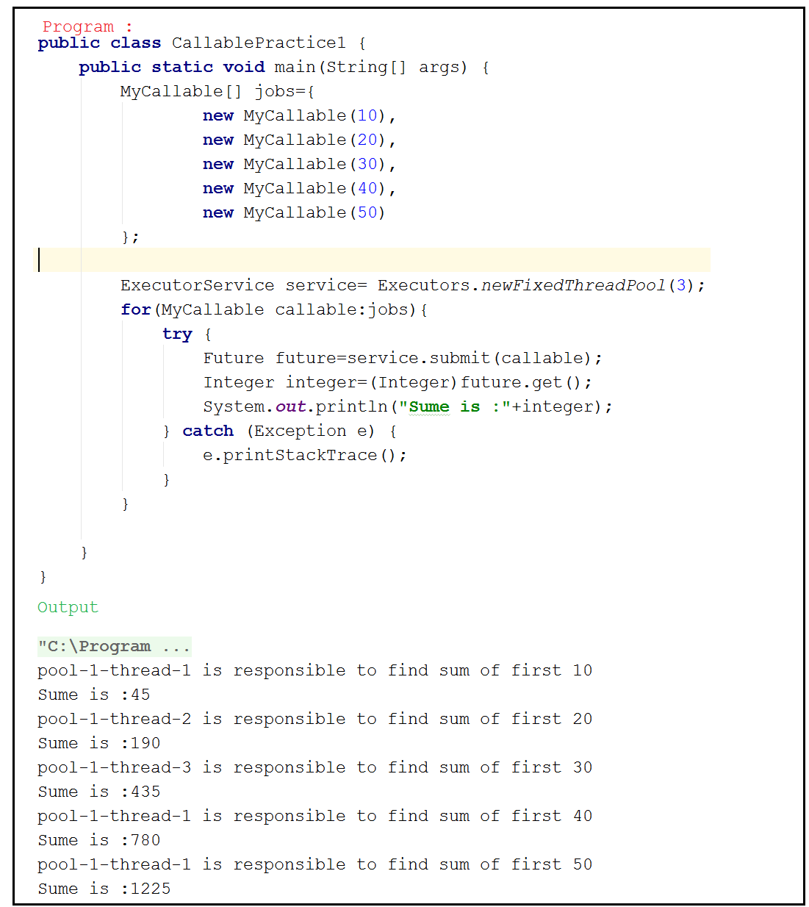

## Difference between Callable & Runnable

|  |  |
| --- | --- |
| **Runnable** | **Callable** |
| If a thread is not required to return anything After completing the job-then we should go for runnable | If a thread required to return something after completing the job – then we should go for callable |
| Runnable interface contain only one method -public void run(){}, | Callable interface contain only one method -call() |
| Runnable job not required to return anything and hence return type of run() method is void | Callable job is required to return something and hence return type of call() method is object. |
| Within the run method if there is any chance of rising checked exception compulsory we should handle by using try-catch because we can’t use throws keyword for run method | Within call() method if there is any chance of rising checked exception we are not required to handle by try-catch block, because call method already throws exception |
| Runnable interface present in java.lang package | Callable interface present in java.util.concurrent package. |
| Introduced in 1.0 version | Introduced in 1.5 version |

# ThreadLocal

This class provides thread-local variables. These variables differ from their normal counterparts in that each thread that accesses one (via its get or set method) has its own, independently initialized copy of the variable. ThreadLocal instances are typically private static fields in classes that wish to associate state with a thread (e.g., a user ID or Transaction ID).

## Property:

1. ThreadLocal class provides ThreadLocal variable. Thread local class maintains values per Thread basis. Each Thread local object maintains a separate value, like user id transaction id etc, for each thread that accesses that object,
2. Thread can access it’s local value can manipulate its value and even can remove it’s value. In every part of the code which is executed by the Thread we can access it’s local variable.
3. Ex: consider a servlet which invokes some business methods. We have a requirement to generate a unique transaction ID for each and every request and we have to pass this transaction id to the business methods. For this Requirement we can use Thread local to maintain a separate transaction ID for every request i.e. for every thread.

Note :

1. Thread Local class introduced in 1.2 version and enhanced in 1.5 version.
2. Thread Local can be associated with **Thread Scope.** Total code which is executed by Thread has access to the corresponding ThreadLocal variables.
3. A thread can access it’s own local variables and can’t access other threads local variables because it’s local to that particular Thread.
4. Once the thread into dead state all its local variables are by default eligible for garbage collection.

## Constructor for Thread Local :

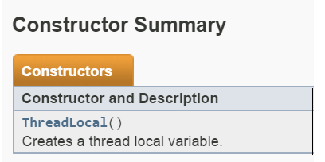

## Mathods :

|  |  |  |
| --- | --- | --- |
|  |  |  |
| 1 | object get() | Returns the value of Thread-local variable associated with current Thread. |
| 2 | object initialValue() | Returns initial value of Thread Local variable associated with current Thread.  The default implementation of this method returns null. To customize our own initial value, we have to override this method. |
| 3 | void set(ObjectNewvalue) | To set a new value. |
| 4 | void remove() | To remove the value of ThreadLocal variable associated with current Thread. |

Methods API :

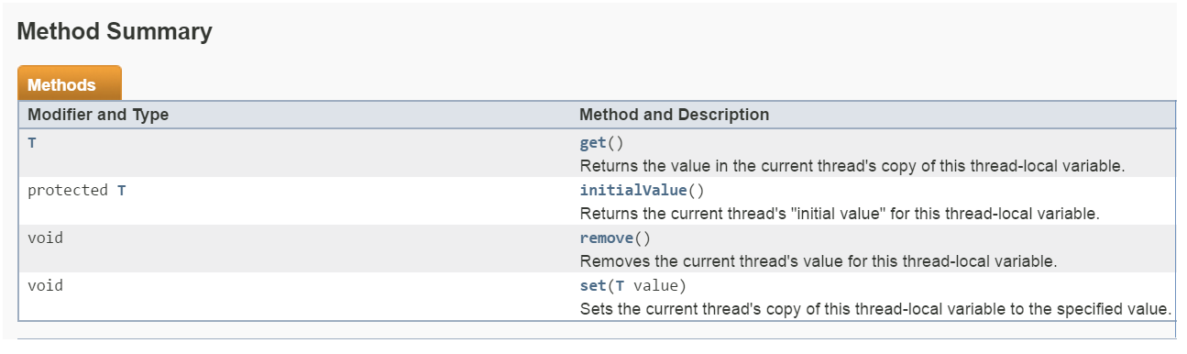

## Programs

### Scenerio 1:

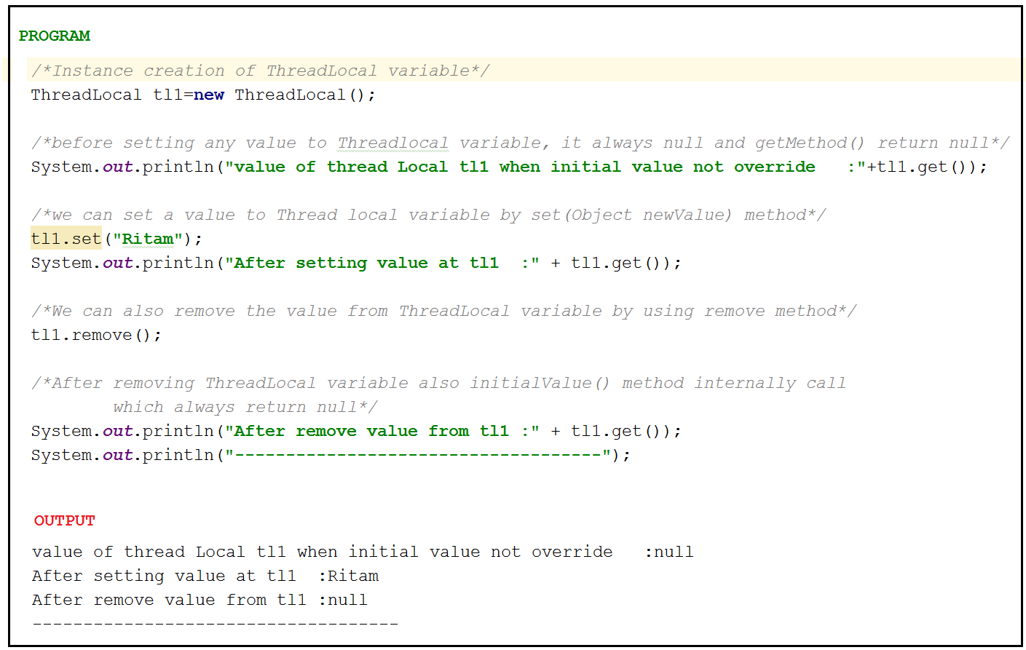

QUESTION :

Can we override initial value of Theadlocal variable ?

Answer: Yes, we can override ThreadLocal variable

### Scenerio 2:

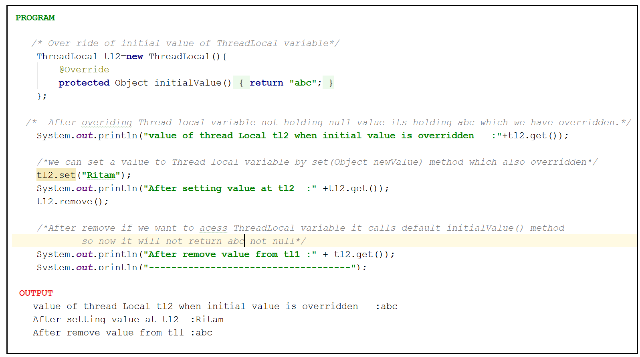

Note :

Once after remove if we want to access thread local variable it always call initialValue() method. If we have not overridden initialValue() method it always return null otherwise our overridden value.

### Scenerio 3

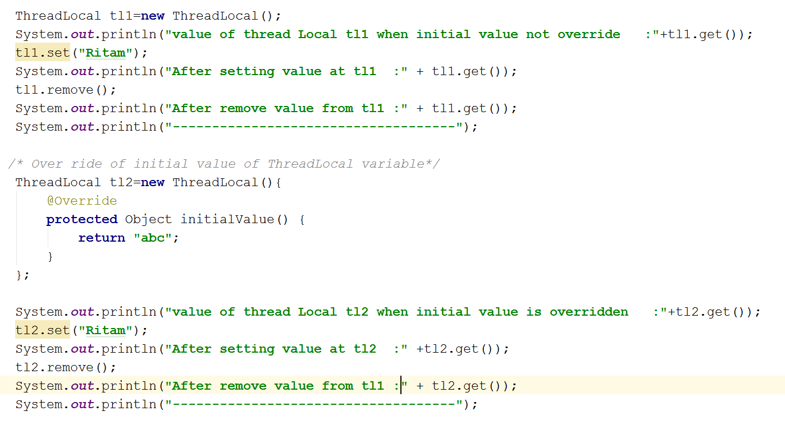

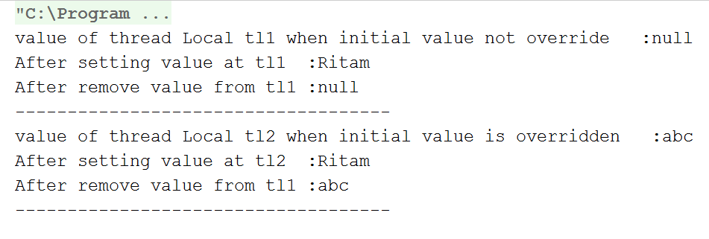

### Scenario 4

Implementation example of Thread local :

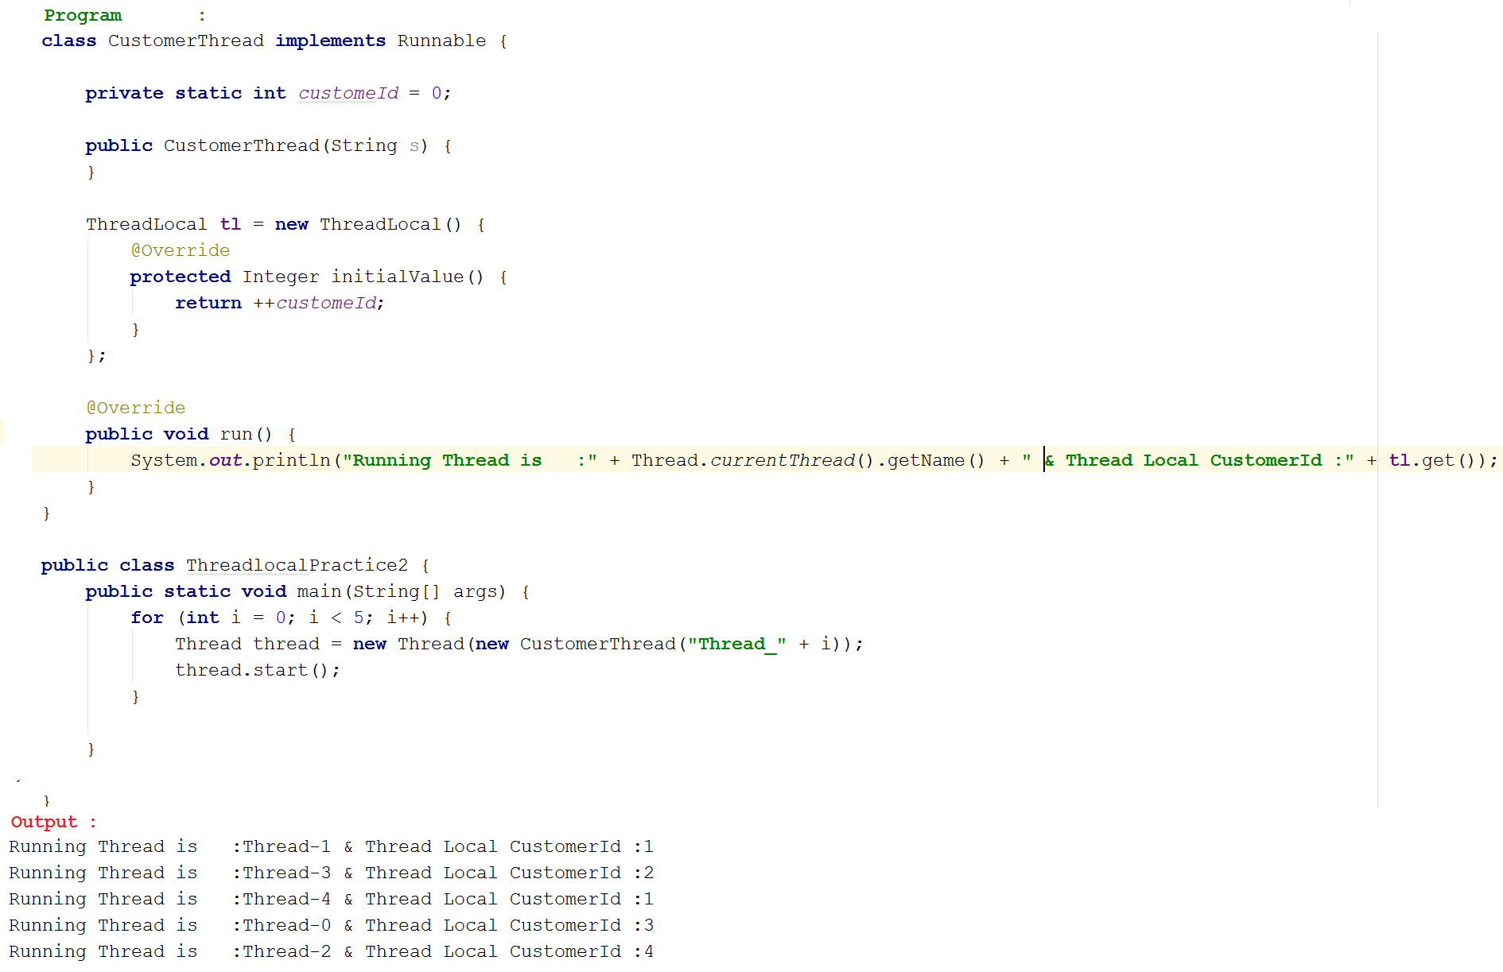

In above program for every customer thread a separate customerId will be maintained by ThreadLocal object

* String getName() : returns name of the thread
* Int getMaxPriority() : returns max. [priority of Threadgroup()
* Void setMaxpriority(int p) : to set maximum priority of ThreadGroup() [ the defaultmax. Priority is 10]

### Scenerio 5

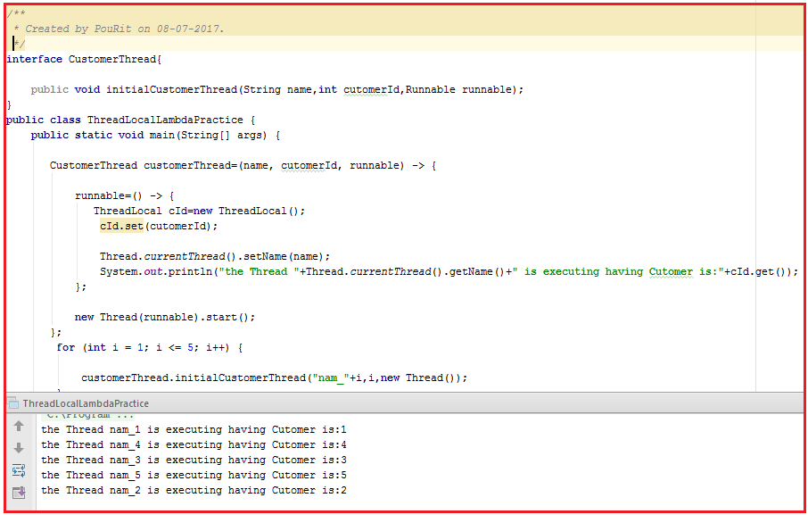

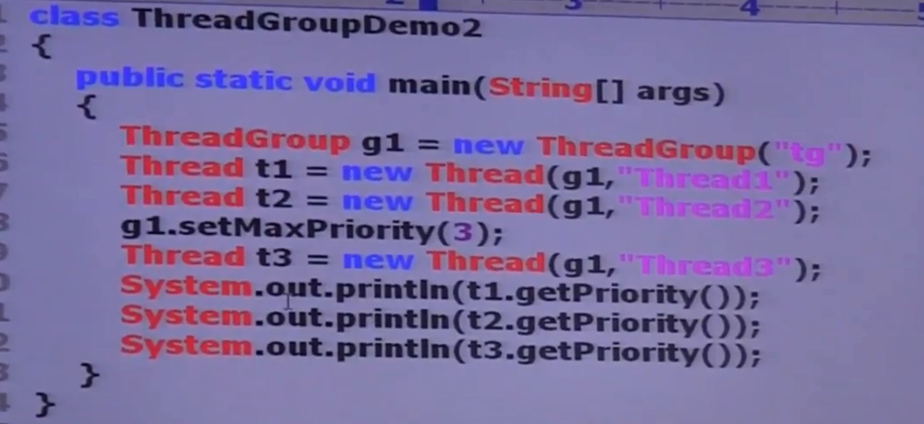

Here output will be 5,5,3 because no drop down for higher priority thread which already created.

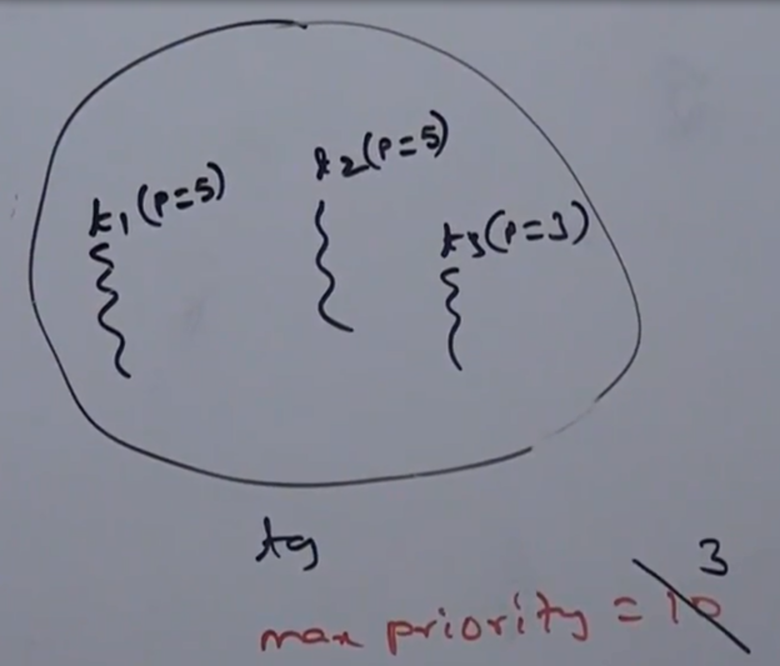

ThreadLocal vs Inharitance :

If we set any value to parent thread and from parent thread start execution of child Thread, we can’t get value which we have set from child Thread because value is not set in child thread scope.

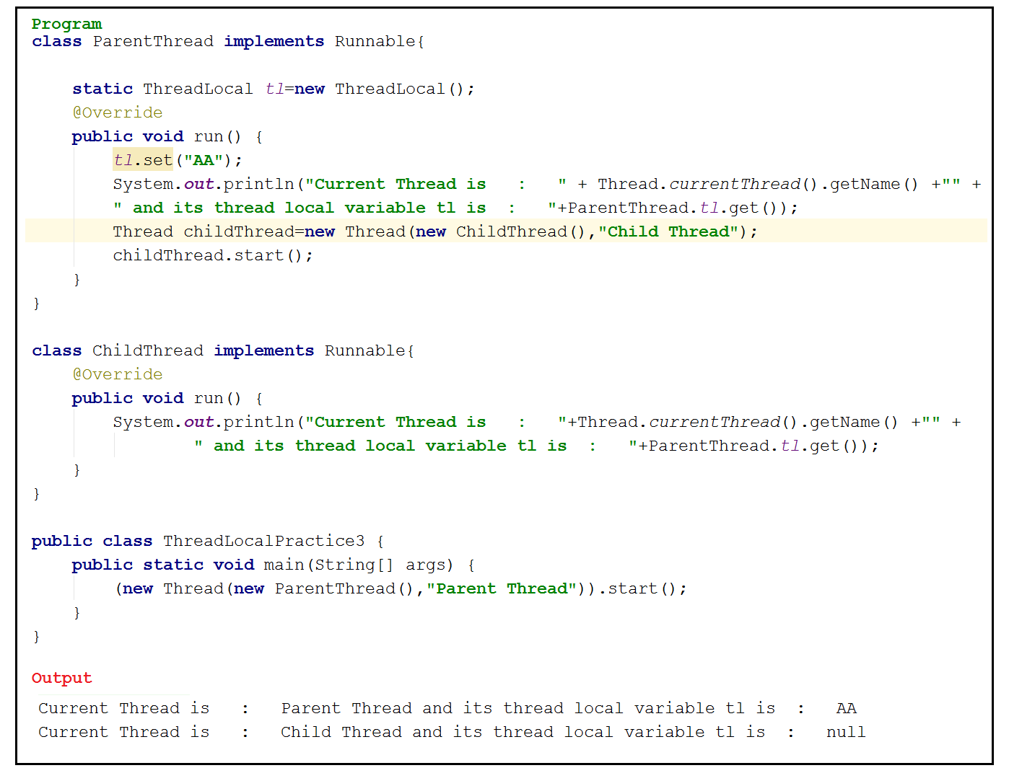

#### InheritableThreadLocal

1. Parent Thread’s ThreadLocal variable by default not available to the Child thread. If we want to make parent Thread’s threadLocal variable value, available to the child thread then we should go for **IinharitableThreadlocal**” class.
2. By default Child Thread’s value is exactly same as Parent Thread’s value but we can provide customized value for child thread by overriding childValue() method.

Constuctor :

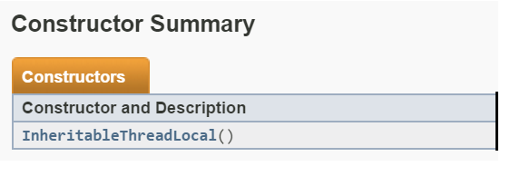

InharitableThreadLocal itl=new InheritableThreadLocal();

Methods :

inheritableThreadLocal is child class of ThreadLocal and hence all method present in ThreadLocal class also available at InheritableThreadLocal;

In addition to this, it’s contain only one method :

Public Object childValue(Object parentValue)

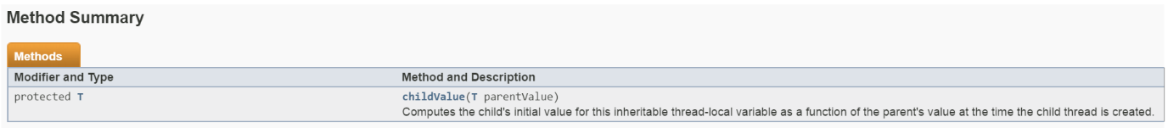

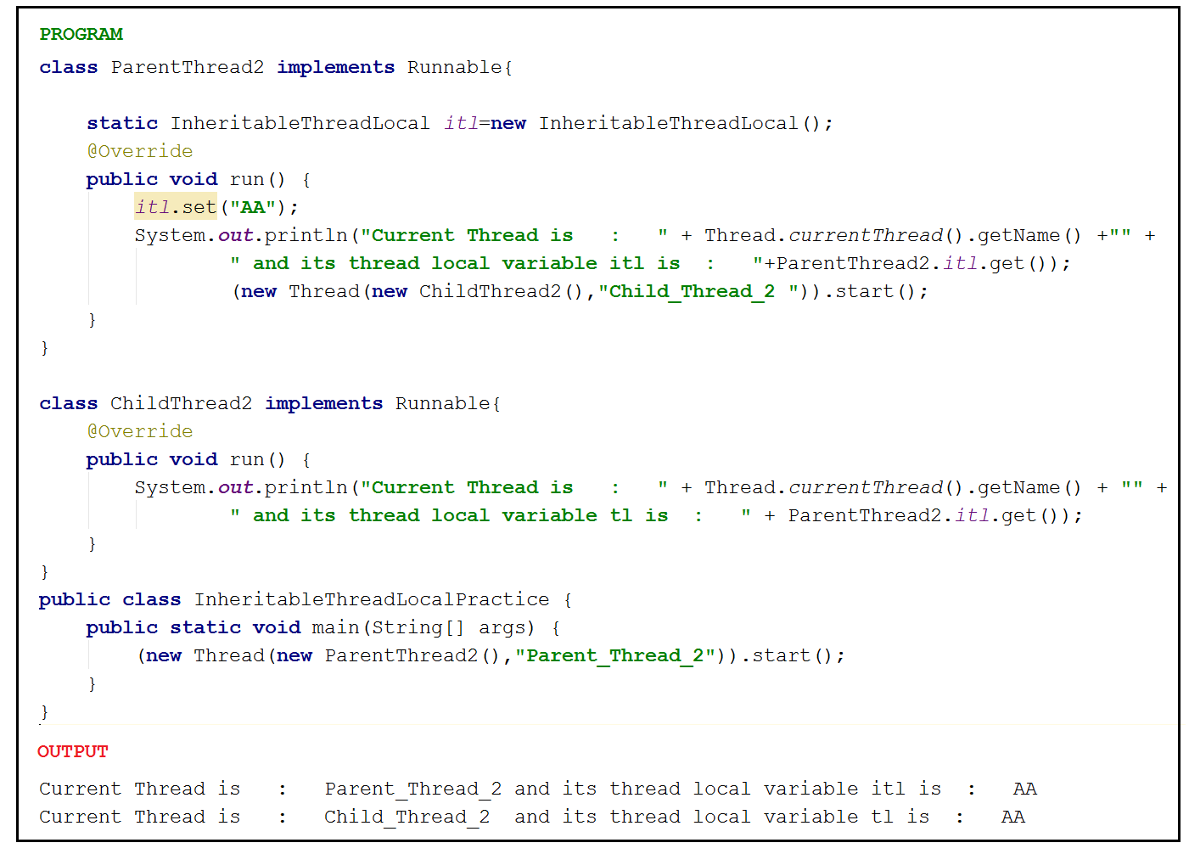

*Example of overriding of* ***childValue****() method in* ***InheritableThreadLocal*** *class :*

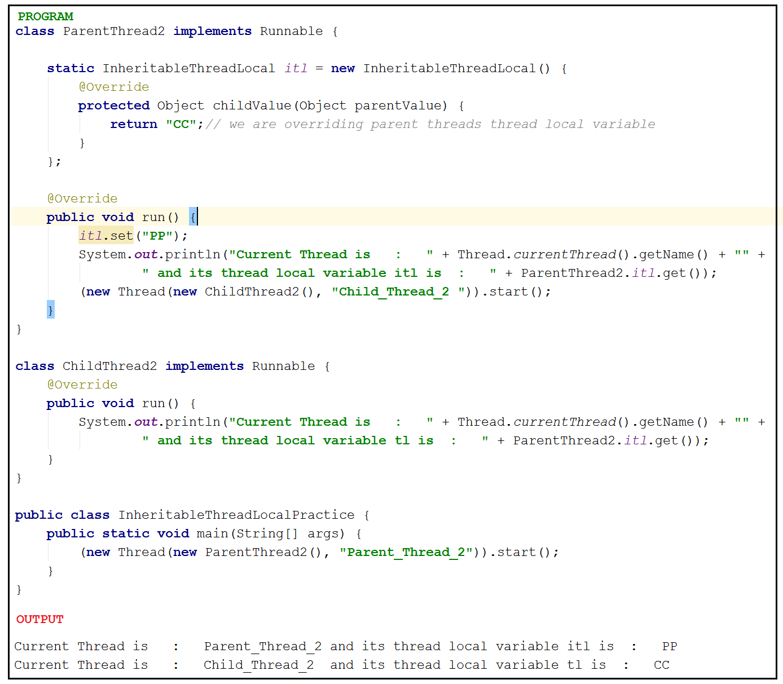

Note :

* In the above program if we replace InheritableThreadLocal with ThreadLocal & if we are not overriding child value method then the .parent Threadlocal Value will be PP and childThreadValue will be null
* If we are maintaining InheritableThreadLocal and not overriding childValue()method both threadLocal value will hold PP.

**Cave of Programming**

1. There are multiple classes in java which are really thread safe and we can really safely access by multiple threads without worrying about thread safety and we don’t have to do Synchronization.
2. A CountDownLatch is initialized with a given count. The await methods block until the current count reaches zero due to invocations of the countDown() method, after which all waiting threads are released and any subsequent invocations of await return immediately.

# CyclicBarrier:

1. Introduced in java 1.5.
2. Contain at java.util.concurrent.
3. Using this we can synchronize a thread which are progressing through some algorithm.
4. Using this we can make threads wait at a point of code until specific number of threads have reached that point of code. Thread will be ordered to wait on call of await method.this is an instanxe level method of CyclicBarrier class
5. CyclicBarrier can be instantiated by CyclicBarrier cb=new CyclicBarrier(n) method. This means cyclic barrier hold n threads and until this n threads reach specific point rest of the code will not execute.

1.